Cognizant Technology Solutions



A Project Report on

“EMPLOYEE PERFORMANCE TRACKING”

Prepared By

|  |  |
| --- | --- |
| Ankita Shivane | 2320390 |
| Bhavesh Uprikar | 2320803 |
| Harshit Yadav | 2320382 |
| Mimansa Yadav | 2320956 |
| Nandhini T | 2320539 |
| Rajanya Kamilya | 2320828 |
| Shambhavi Shukla | 2320529 |

REQUIREMENTS

**Employee Performance Tracking:**

• Import employee performance data into Amazon Redshift.

• Track employee performance metrics such as sales targets, customer satisfaction ratings, and productivity.

• Identify top-performing employees by analyzing performance metrics and comparing them to predefined targets or benchmarks.

• Identify areas for improvement by analyzing performance gaps and providing targeted training or support.

• Visualize employee performance data using charts and graphs (e.g., bar charts, radar charts) to identify trends and patterns.

INDEX

**TOPIC**

1. PURPOSE
2. PICTORIAL FLOWCHART
3. DESIGN & ARCHITECTURE

3.1. VPC

* VPC CREATION
* SUBNET
* INTERNET GATEWAY
* ROUTE TABLE
  1. EC2
* EC2 INSTANCE
* SECURITY GROUP

3.3. S3

* BUCKET CREATION

3.4.IAM ROLE ASSOCIATION

* IAM ROLE

3.5. REDSHIFT

* CLUSTER CREATION
* CONFIGURE VPC, CLUSTER SUBNET GROUP, SECURITY GROUP

4. QUERY GENERATION

5. VIRTUALIZATION

6.CONCLUSION

**PURPOSE:**

* **Data Analysis:** Perform complex analytics on large datasets stored in S3 using the powerful querying capabilities of Redshift.
* **Business Intelligence (BI):** Create reports, dashboards, and visualizations from data stored in S3 by loading it into Redshift for BI purposes.
* **Data Warehousing:** Store and organize large volumes of structured and semi-structured data from S3 into Redshift for centralized data warehousing.
* **Data Integration:** Integrate data from multiple sources stored in S3 into a single data warehouse in Redshift for comprehensive analysis and reporting.
* **Data Migration:** Migrate data from on-premises data warehouses or other cloud storage solutions to Redshift for better scalability, performance, and cost-effectiveness.
* **ETL (Extract, Transform, Load):** Extract data from S3, transform it as needed, and load it into Redshift for further analysis and reporting.
* **Real-time Analytics:** Continuously load streaming data from S3 into Redshift to perform real-time analytics and gain insights into rapidly changing data.
* **Cost Optimization:** Optimize costs by storing raw or historical data in S3's cost-effective storage and transferring only relevant data into Redshift for analysis.
* **Data Archiving:** Archive historical data from S3 into Redshift for long-term storage and analysis while keeping it easily accessible for future reference.
* **Data Governance and Security**: Centralize sensitive data stored in S3 into Redshift for bettergovernance, access control, and security management, ensuring compliance with regulatory requirements.

PICTORIAL FLOWCHART

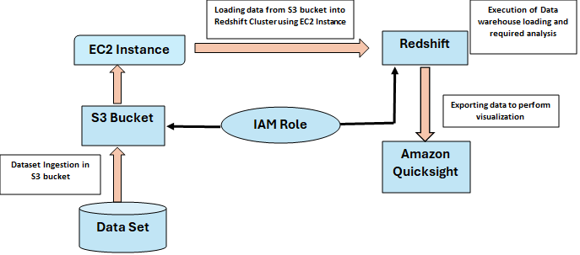

**DESIGN AND ARCHITECTURE**

**VPC CREATION**

**Step 1:** Initiate the VPC creation process, provide the necessary details for your VPC, including the VPC name, CIDR block (the range of IP addresses for your VPC).

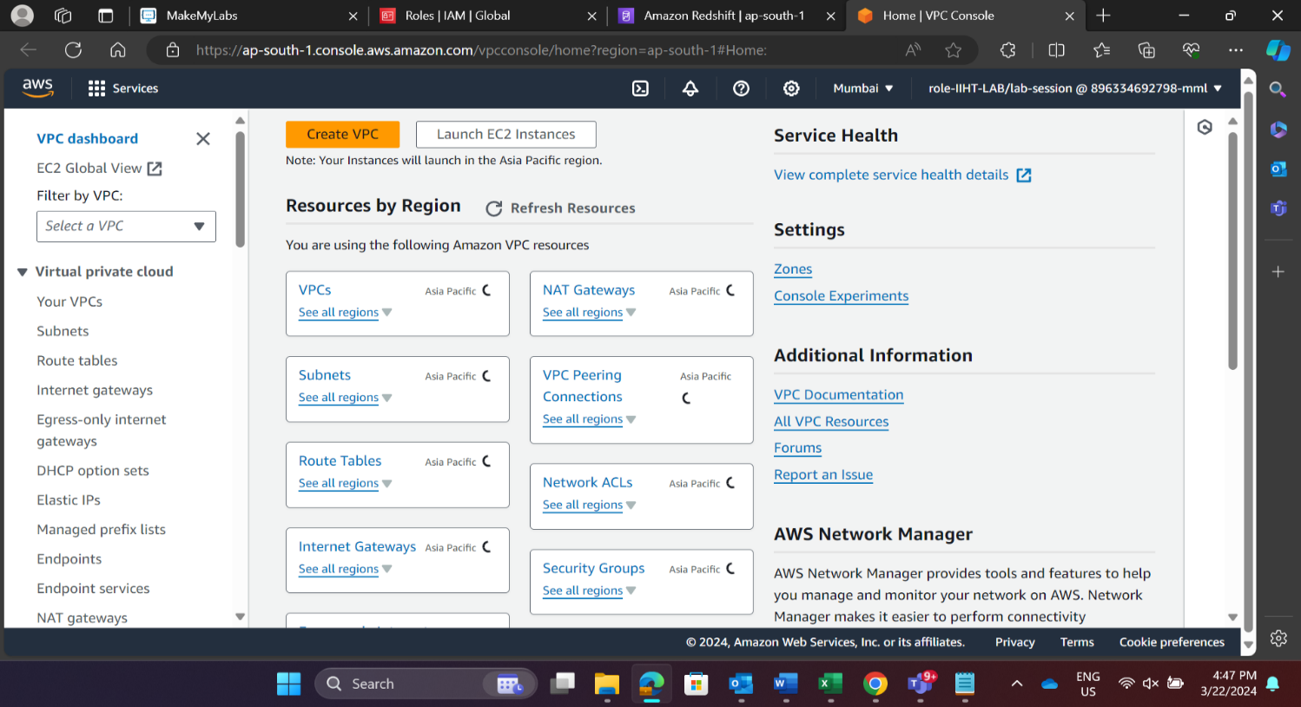



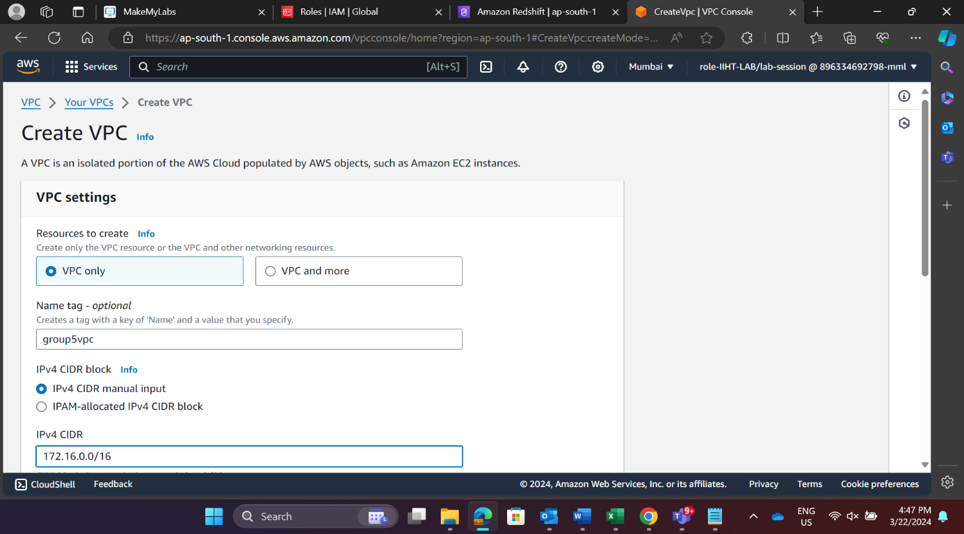

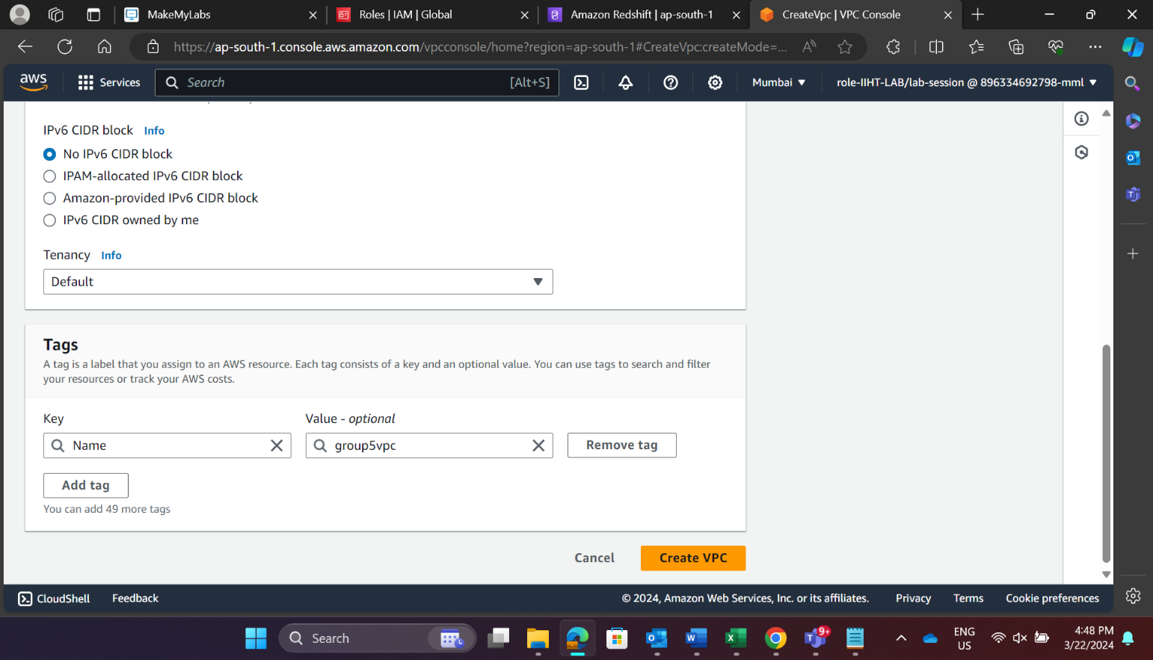

**Step 2:** Define the subnets within your VPC and specify the CIDR block for subnet.

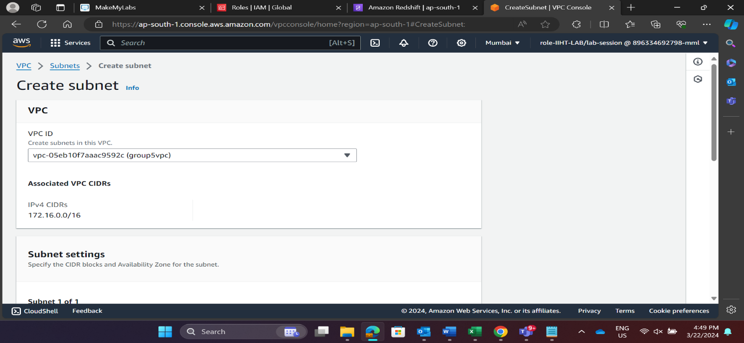

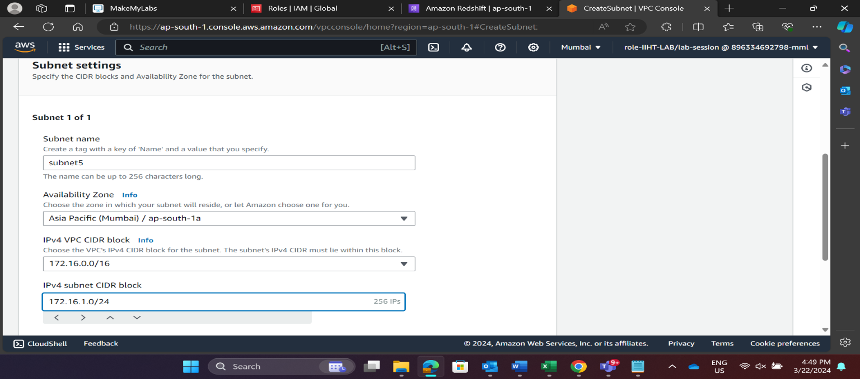

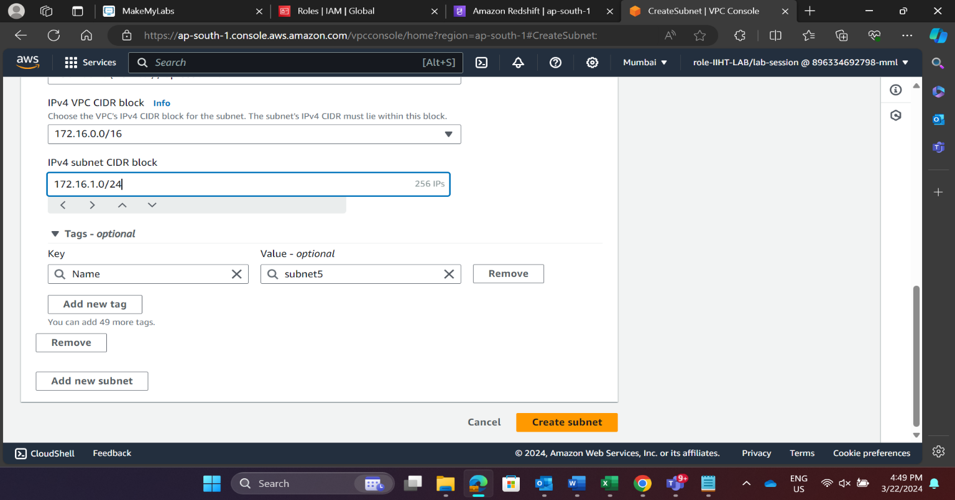

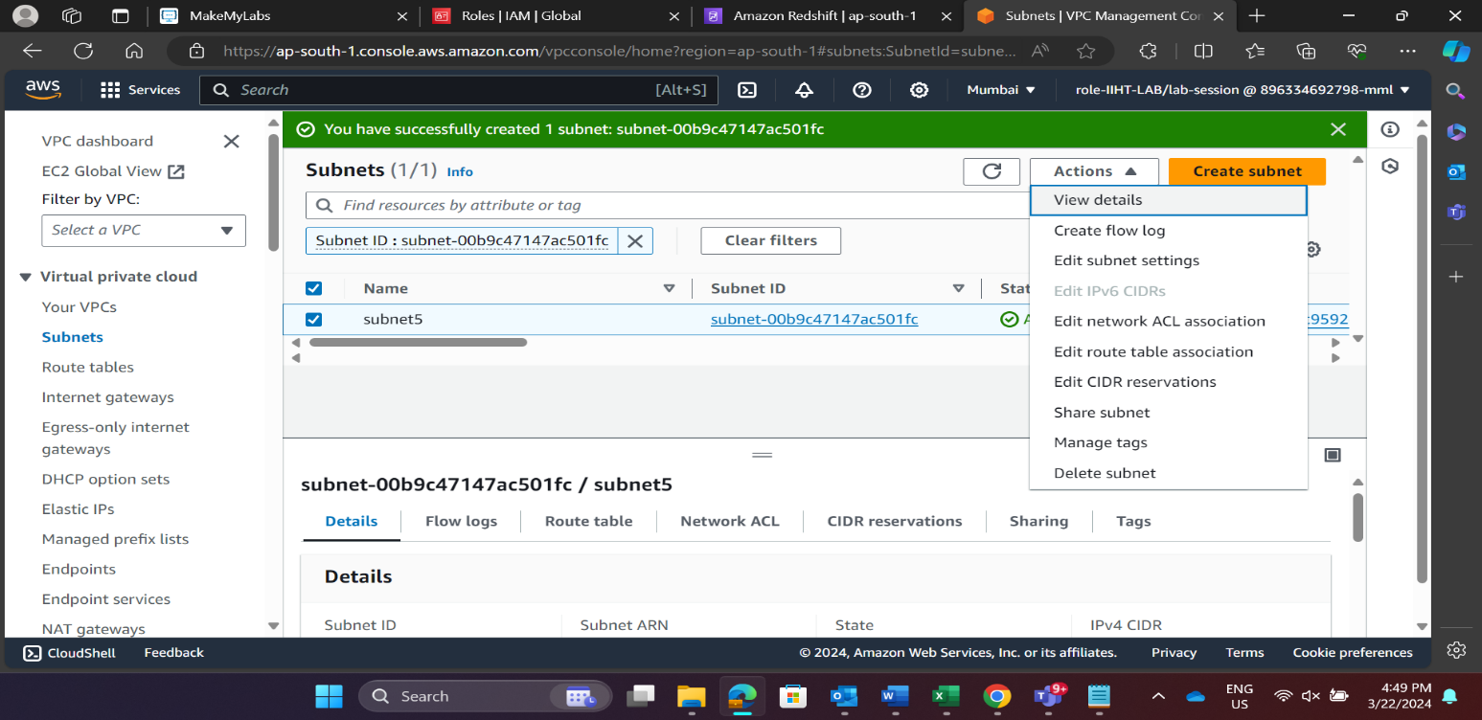

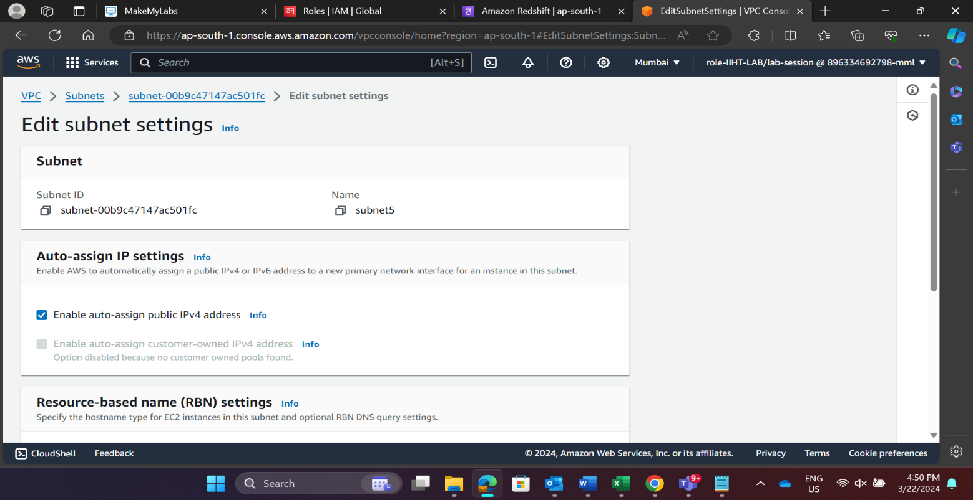

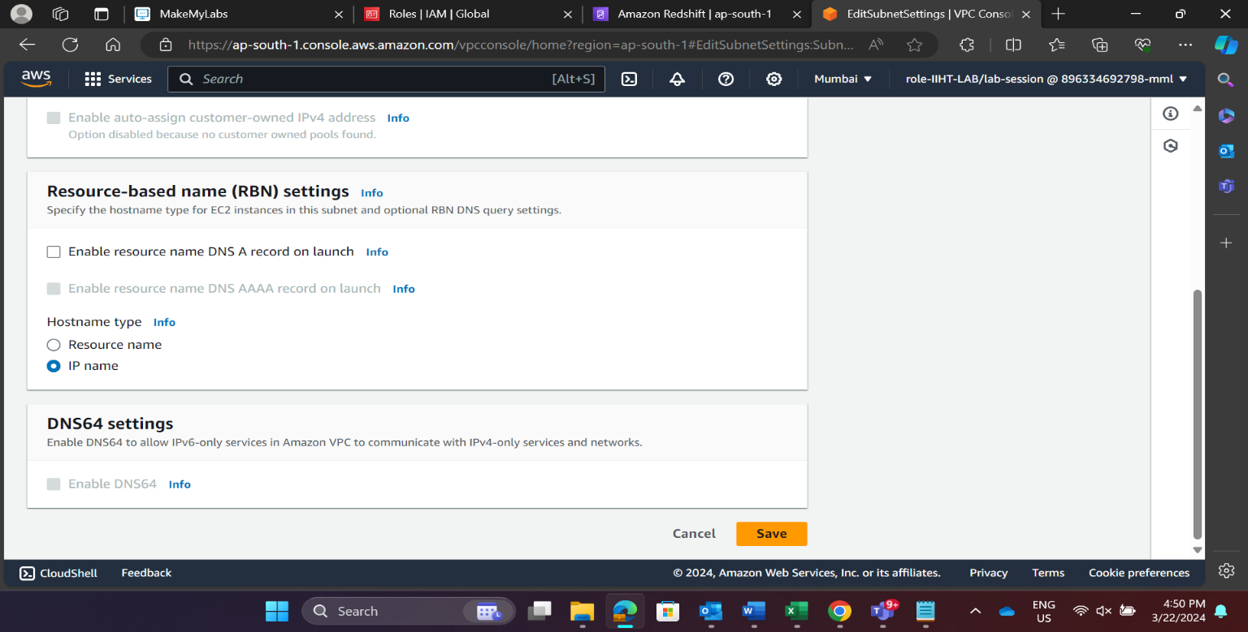

**Step 3:** Configure Internet Gateway: create a new internet gateway, give it a name, and attach it to your VPC.

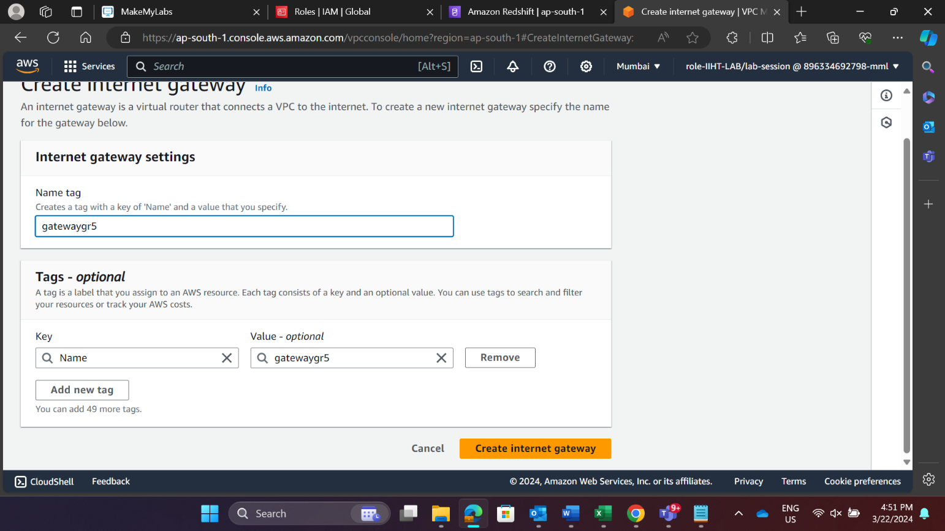

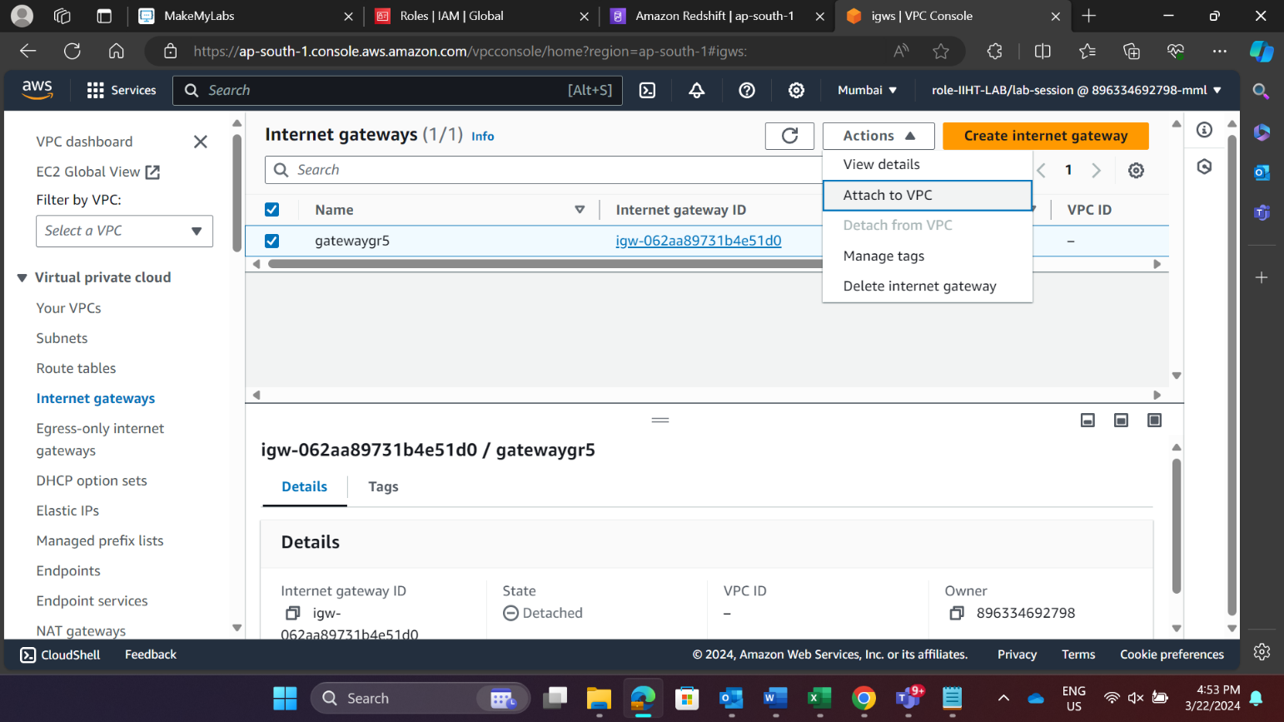

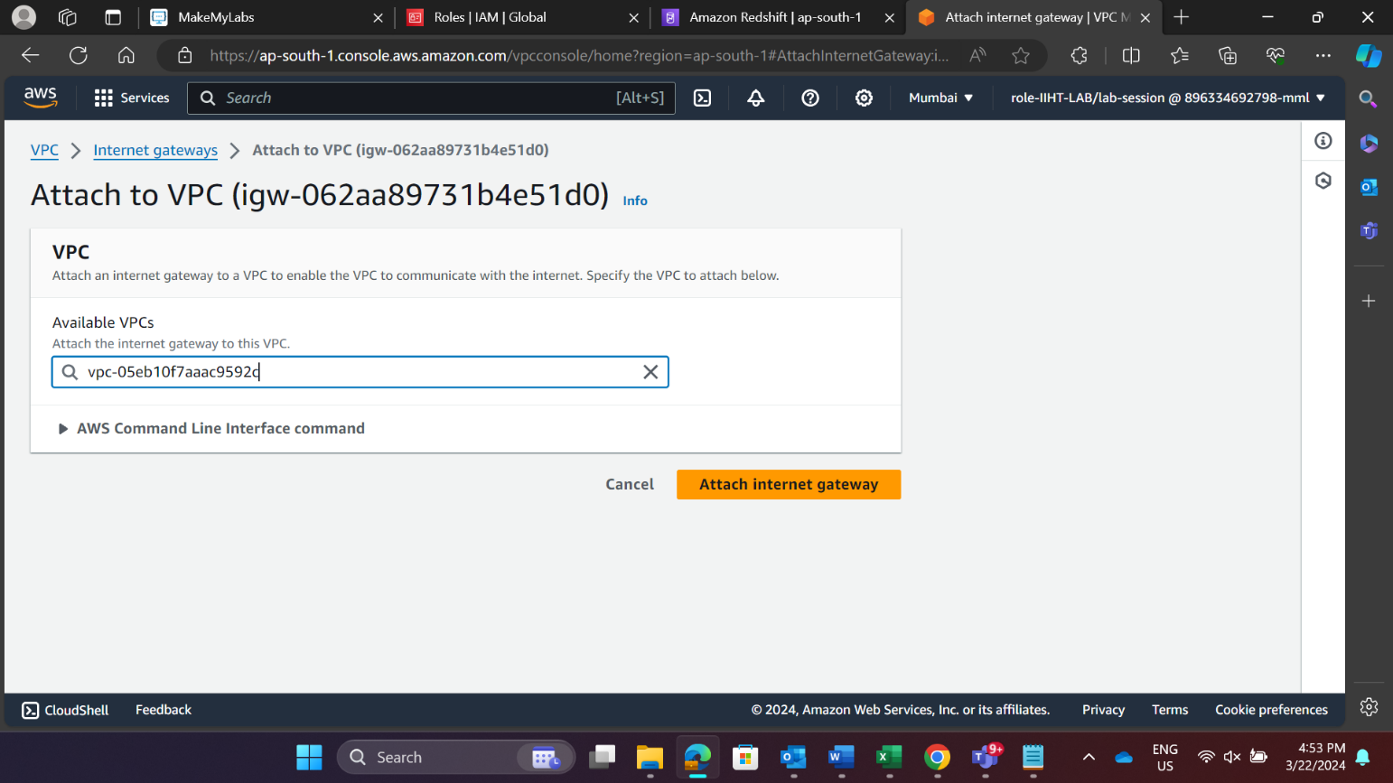

**Step 4:** Configure Route Table: create a route table, give it a name, and attach it to internet gateway.

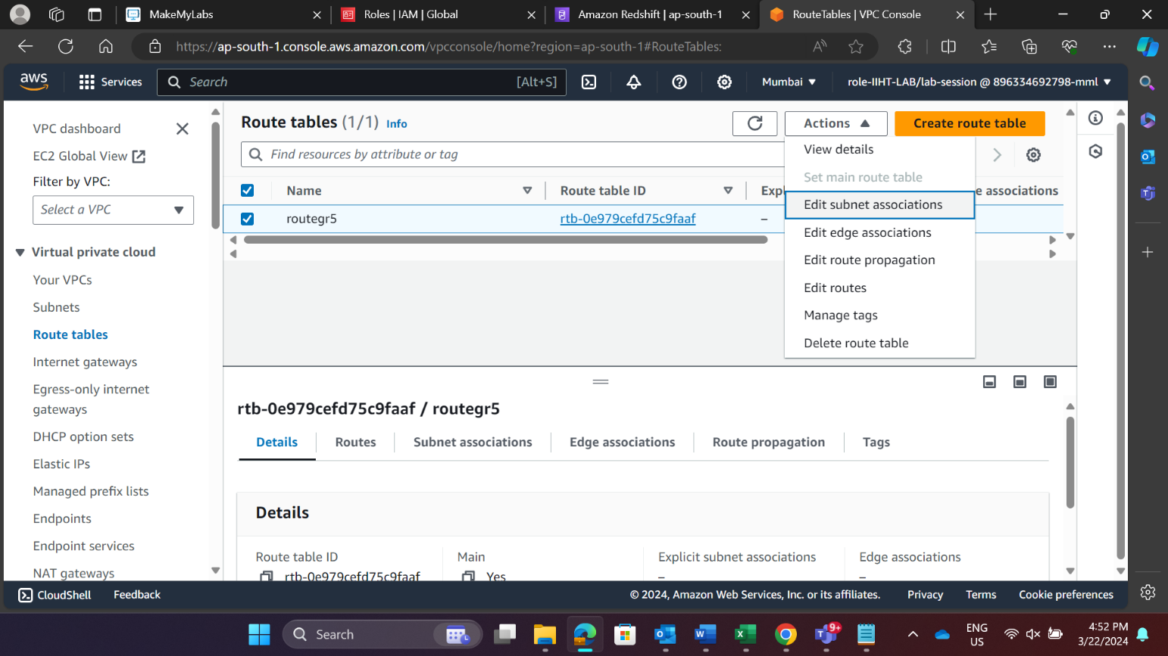

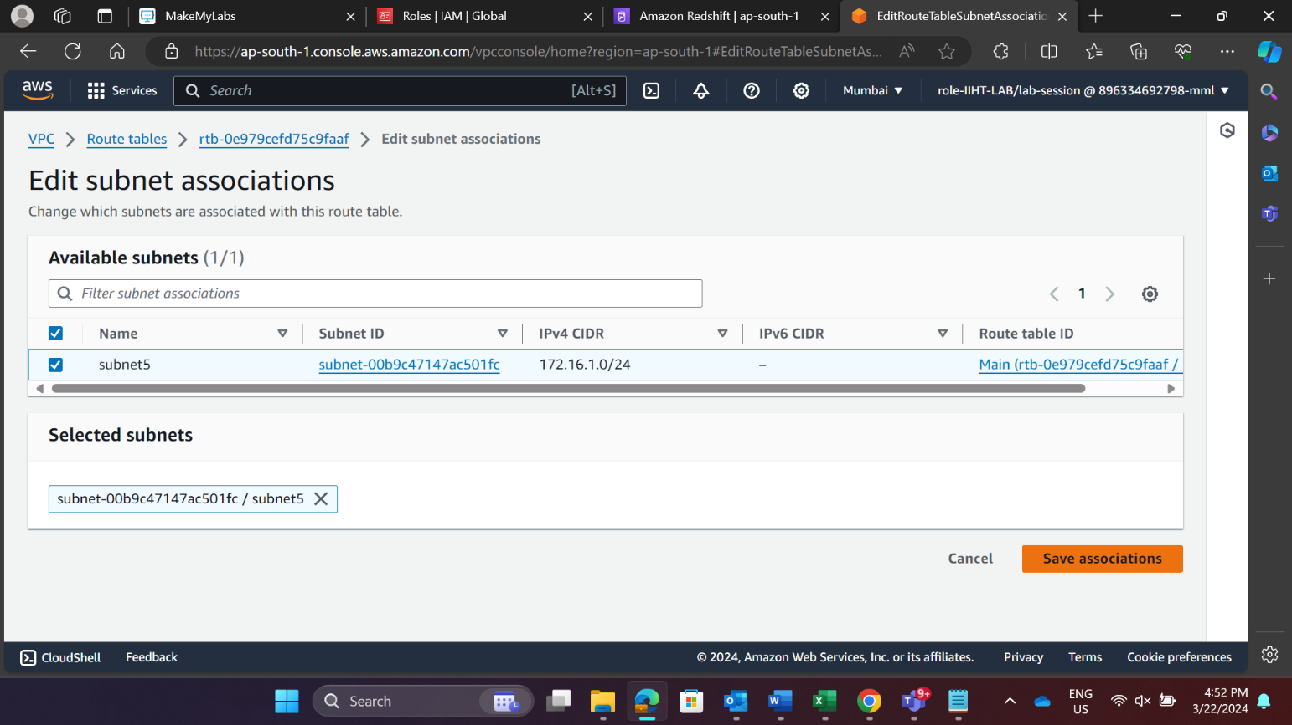

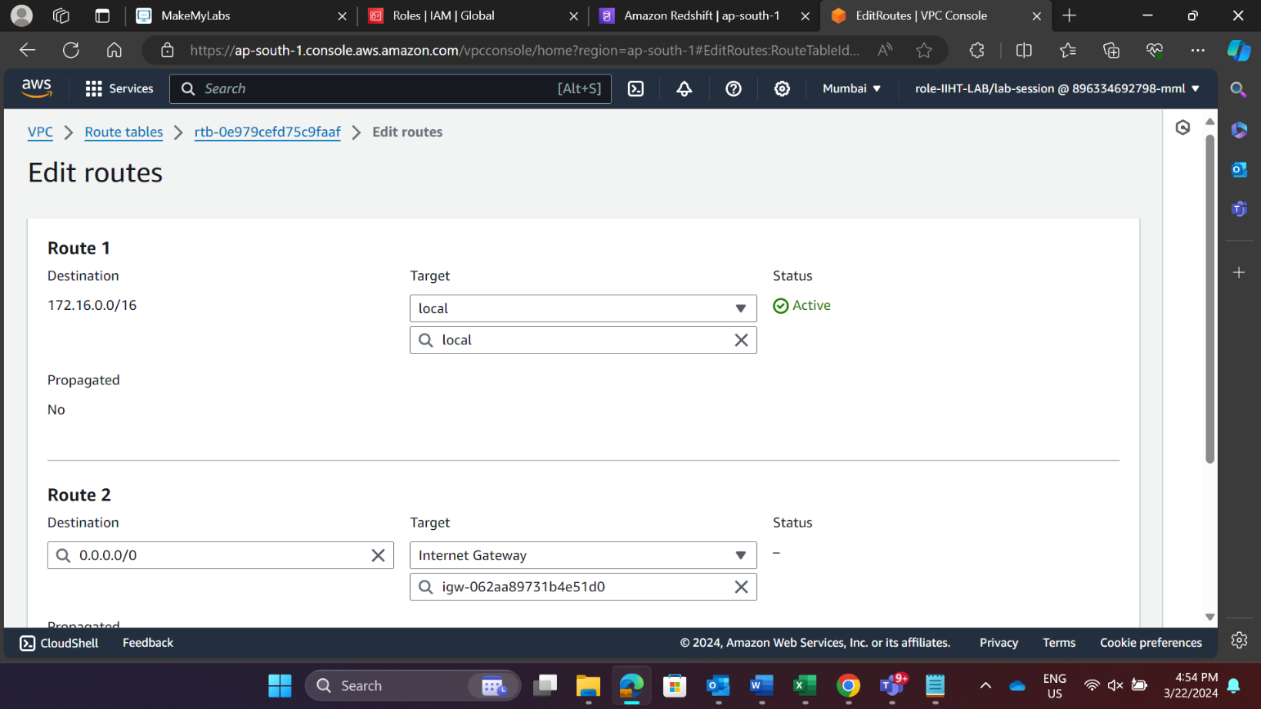

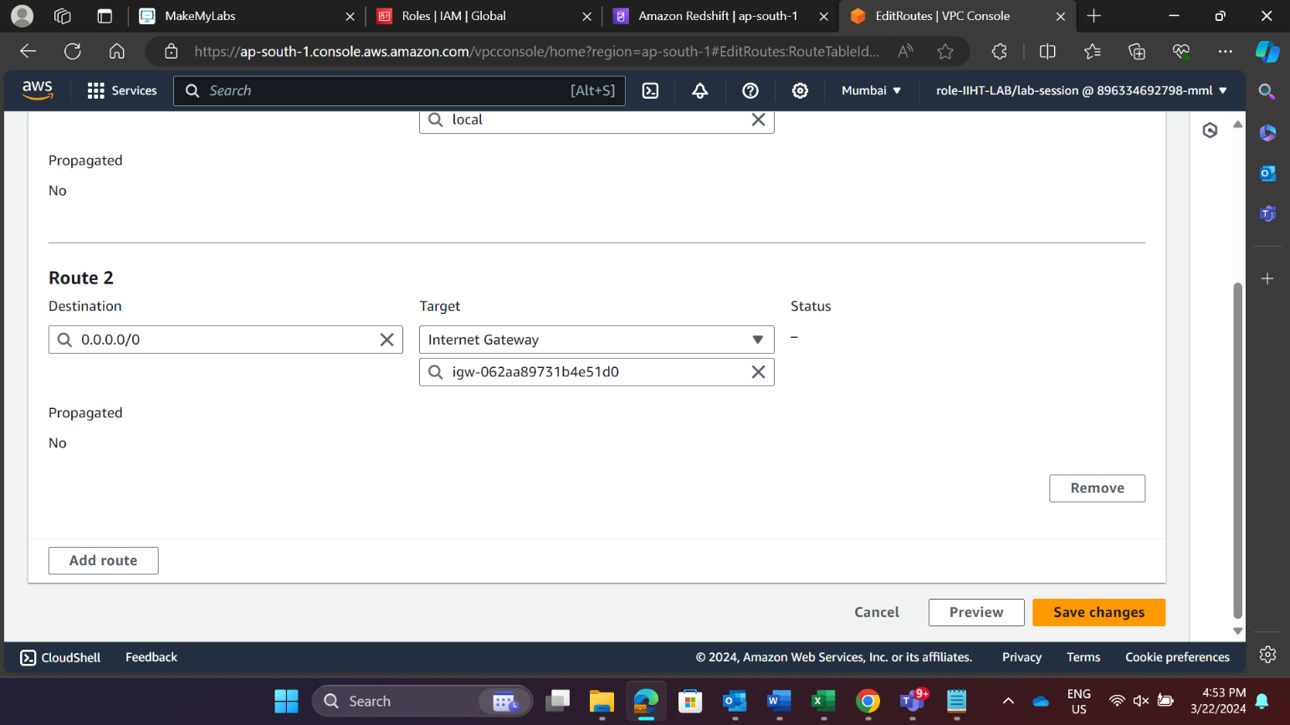

**EC2 INSTANCE**

**Step 1:** On the EC2 dashboard, click the **“Launch Instance”** button. This will start the instance creation wizard.

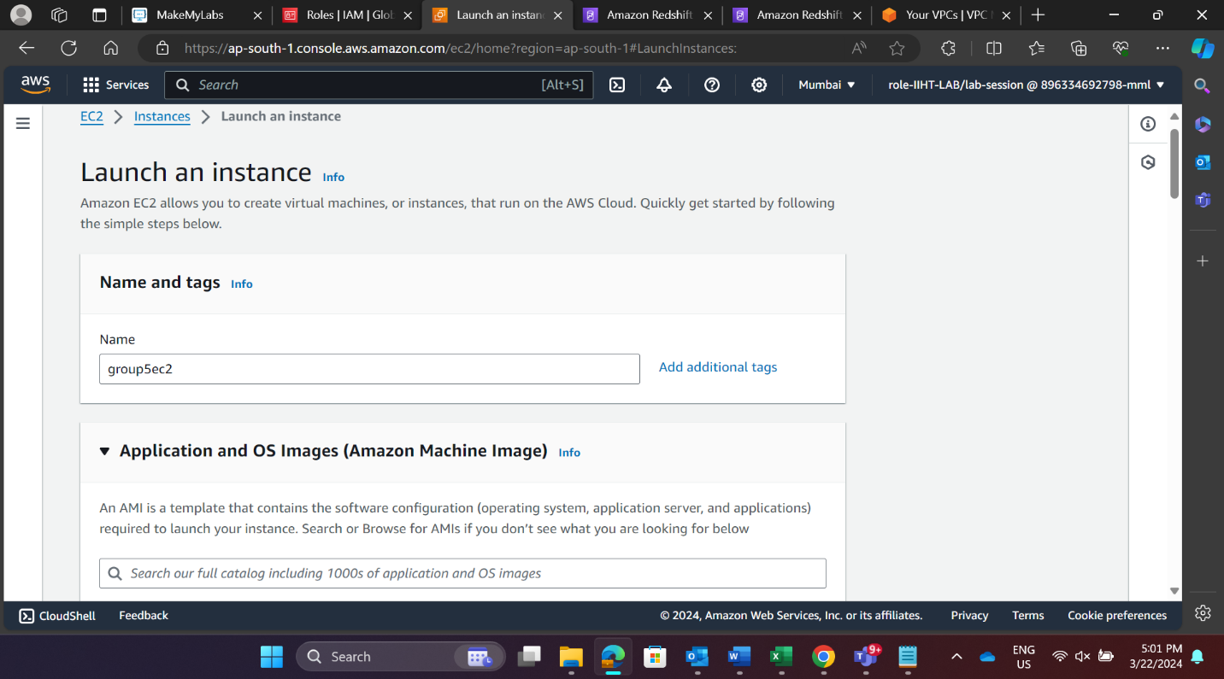

**Step 2: Choose an Amazon Machine Image (AMI). It** is a template for instance’s operating system.

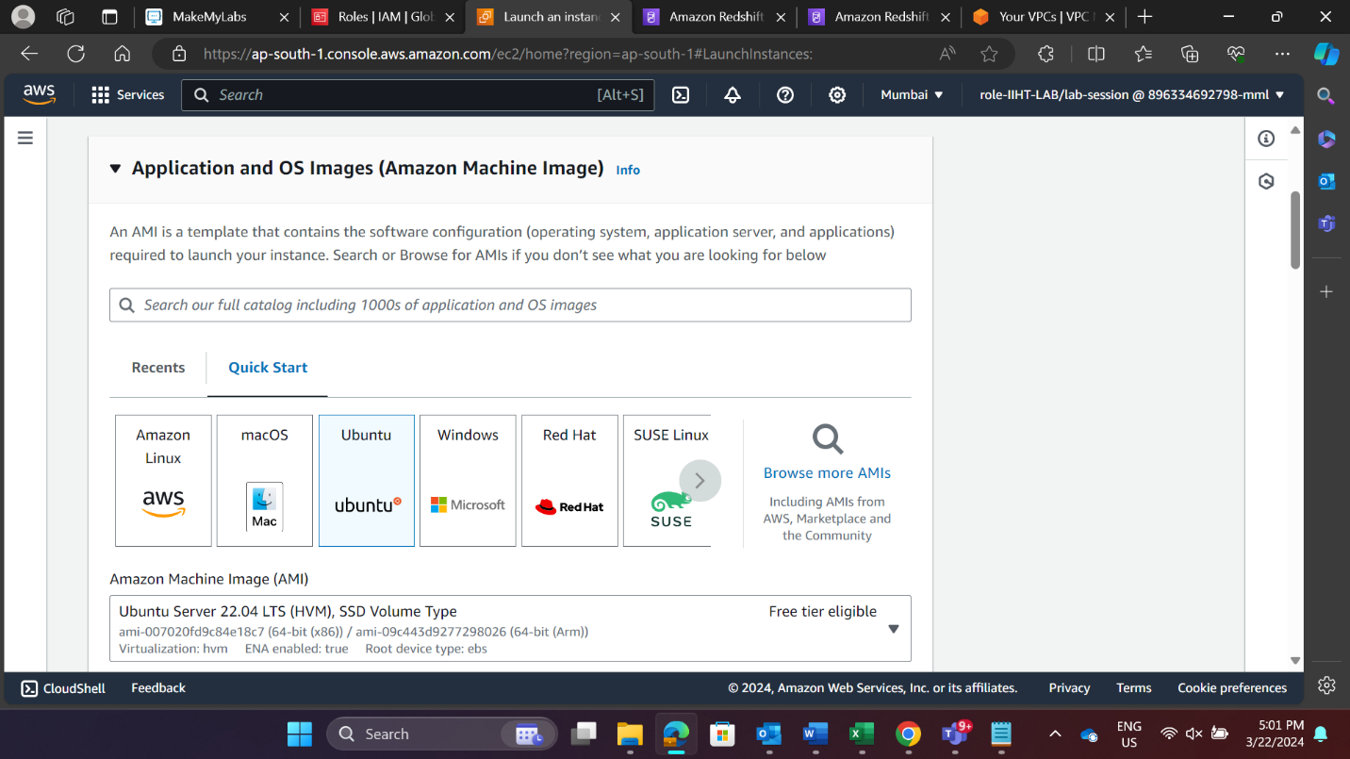

**Step 3:** In this step, select the type of instance based on your business requirements.

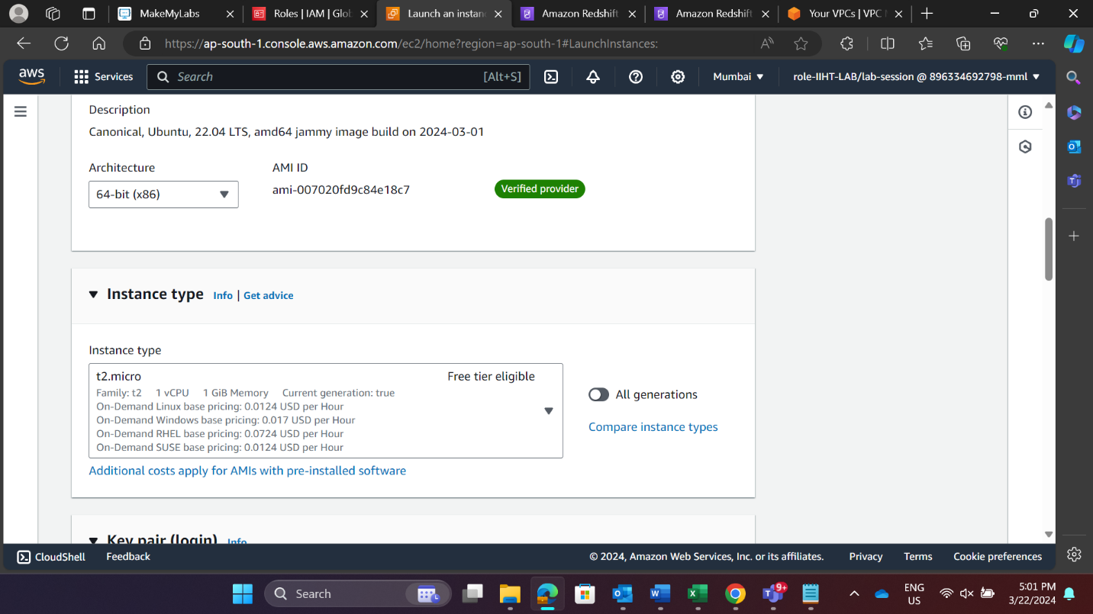

**Step 4:** If you don’t have an existing key pair, create a new one. Download the private key file (.pem) and keep it secure.

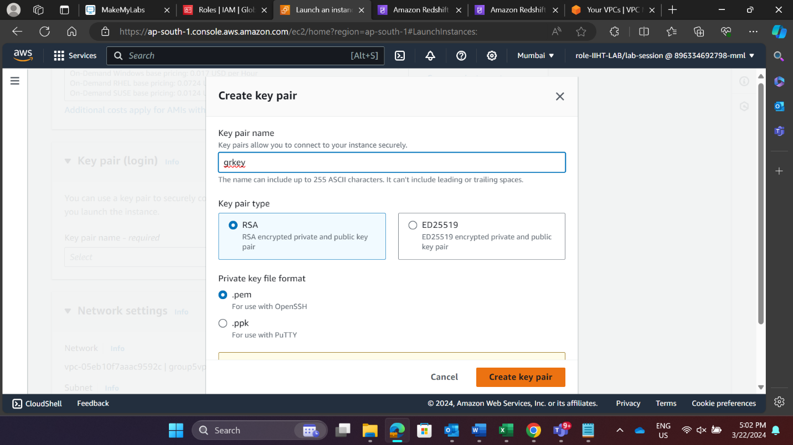

**Step 5:** Set up networking details like VPC, subnet, and security groups.

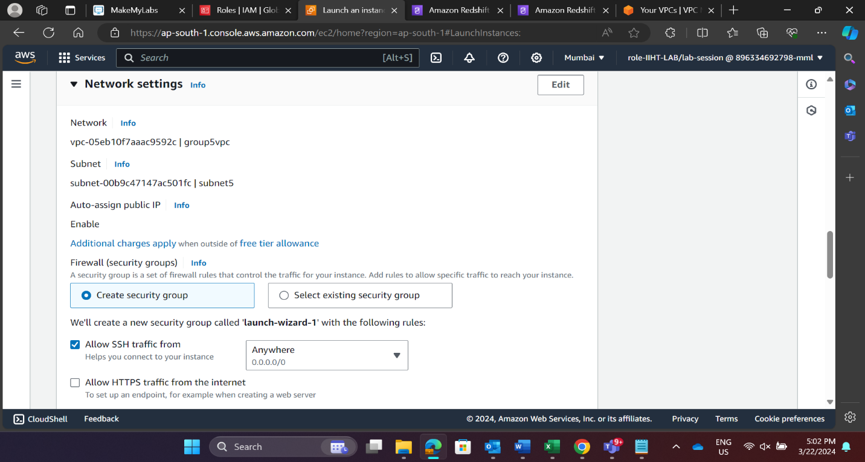

**Step 6:** Add rules for SSH and Redshift in inbound rule for allowing the traffic to redshift cluster.

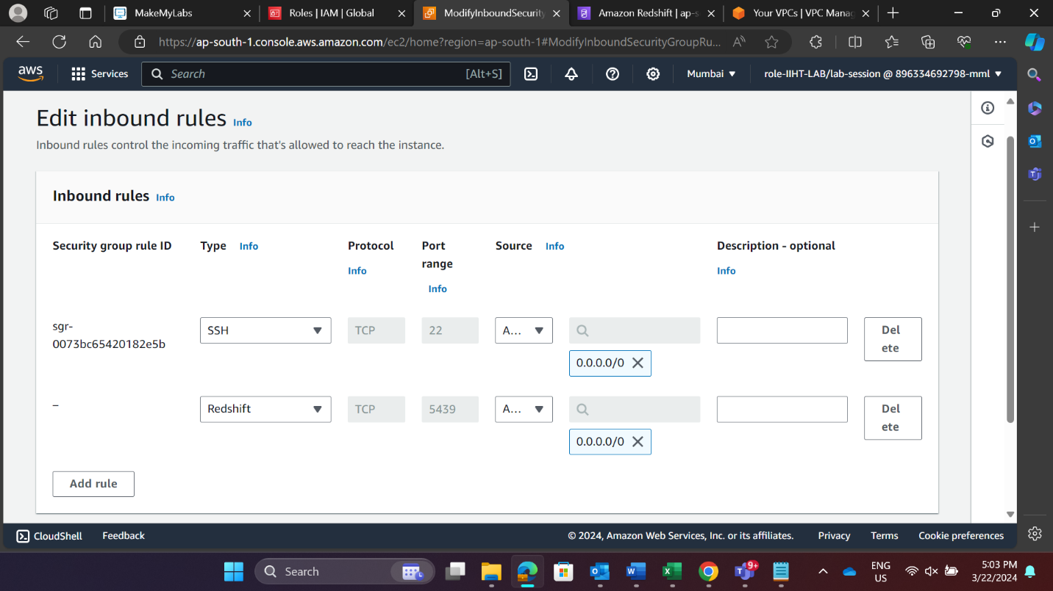

**S3 BUCKET**

Step 1: Create bucket by giving unique name and select the AWS region where you want to create bucket. Configure bucket permissions whether to keep the bucket private or public. After creating bucket add objects.

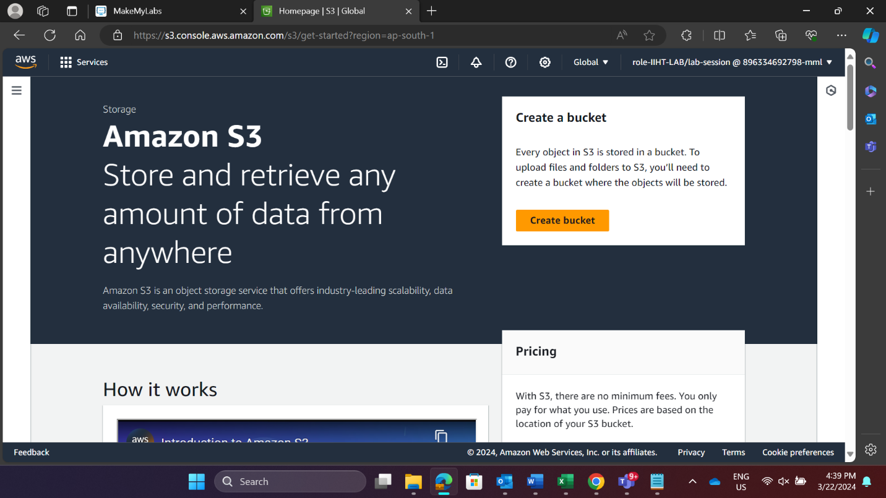

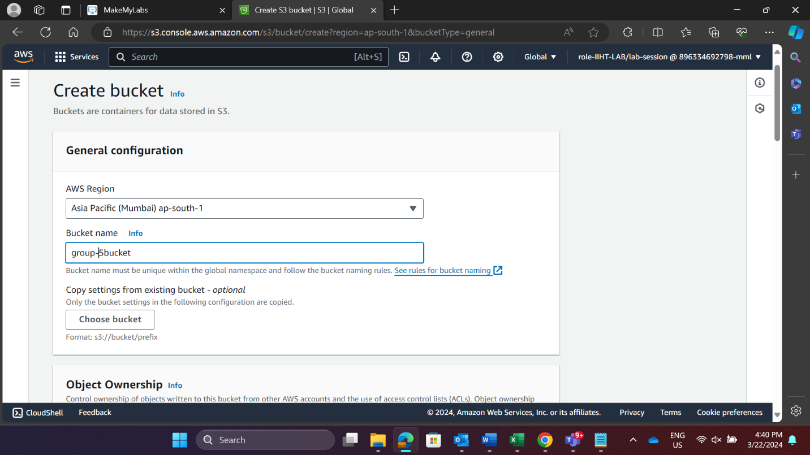

**Step 2:** Configure whether **ACLs (Access Control Lists) are enabled** for the bucket. You can make the bucket accessible to all or restrict access based on your requirements.

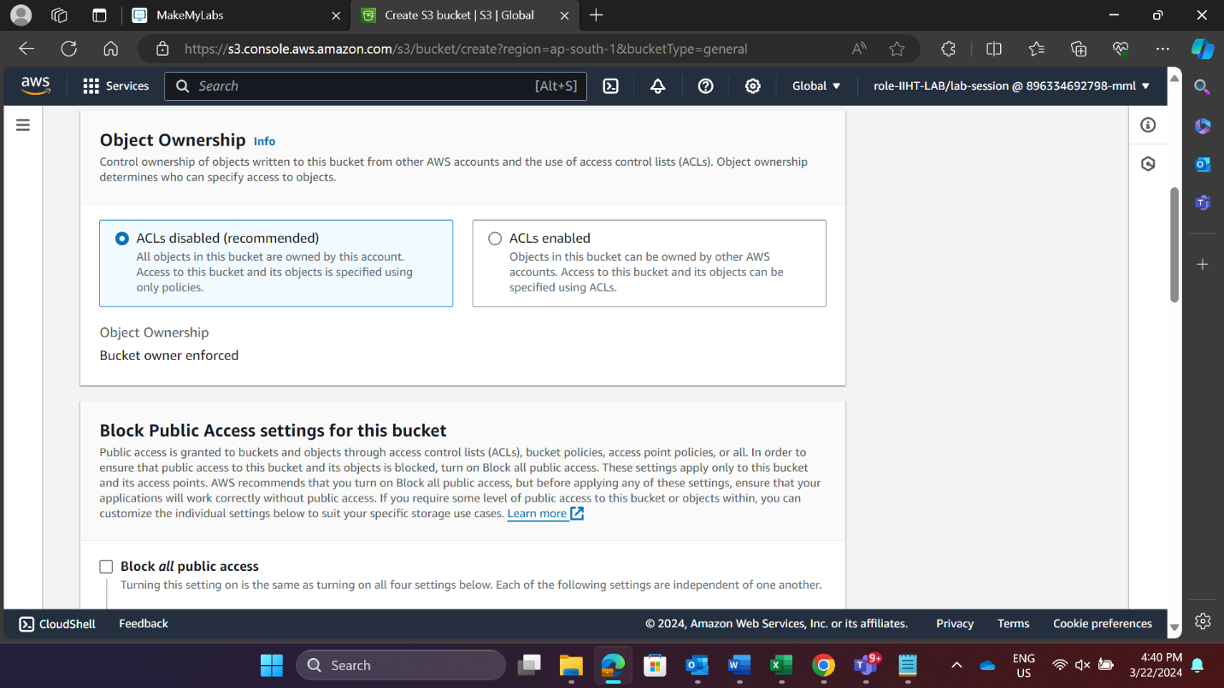

**Step 3:** Selecting SSE with Amazon S3 managed keys and Enabling bucket key.

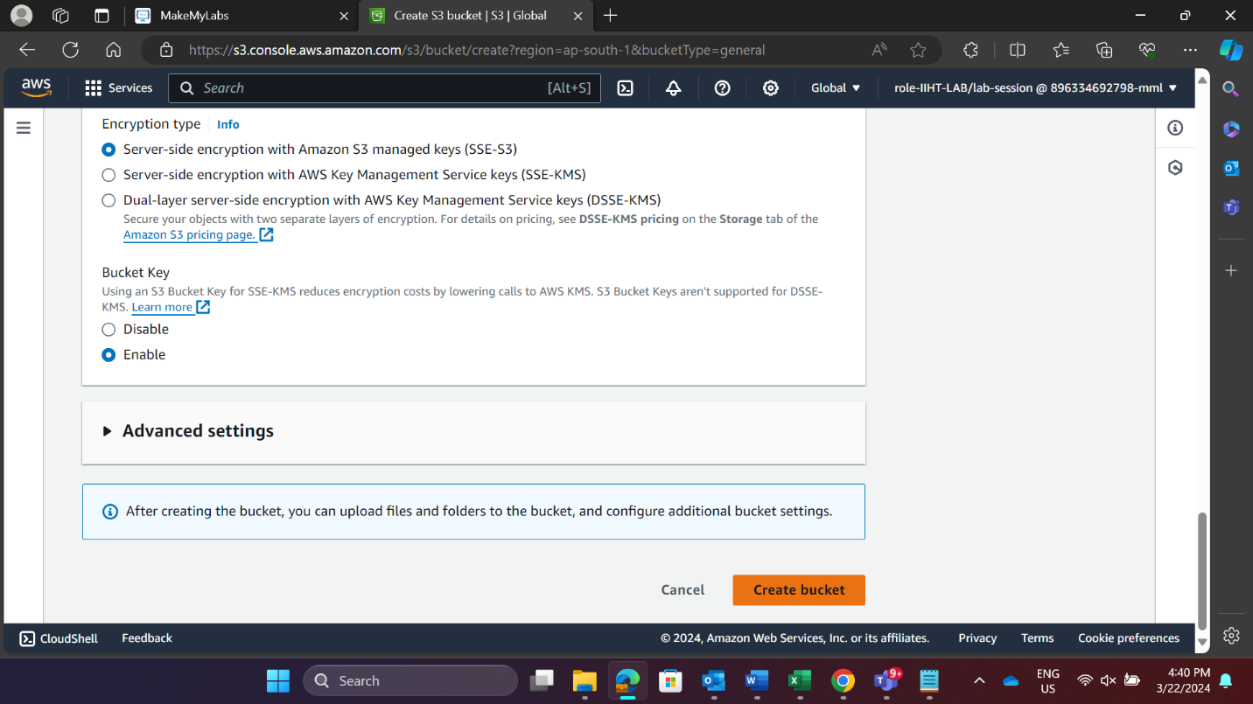

**Step 4:** After creating bucket, upload the file in bucket.

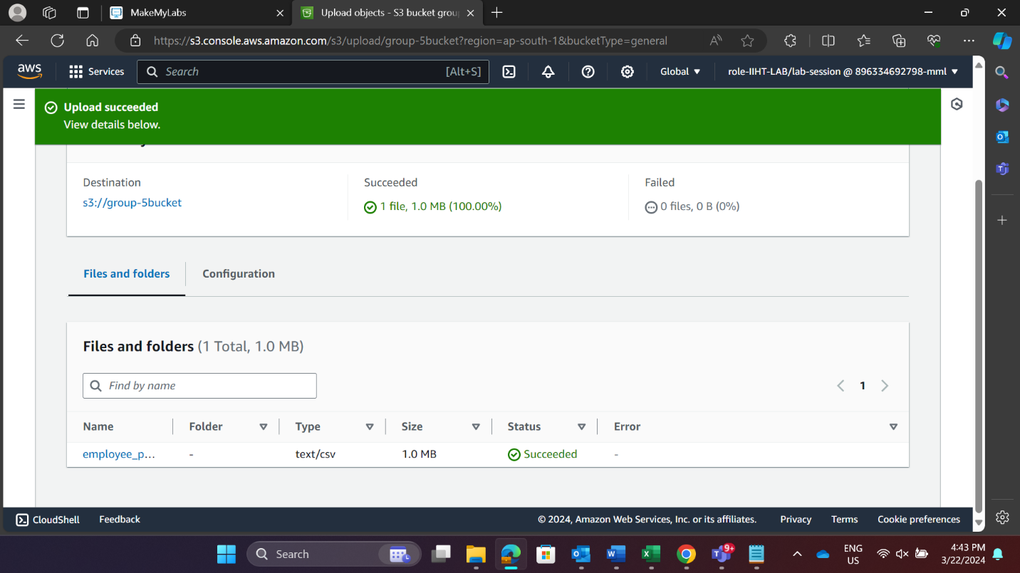

**IAM ROLE ASSOCIATION**

**Step 1:** Navigate the IAM console and create a role, choose redshift that will assume the role and then choose S3 as the service that will use this role.

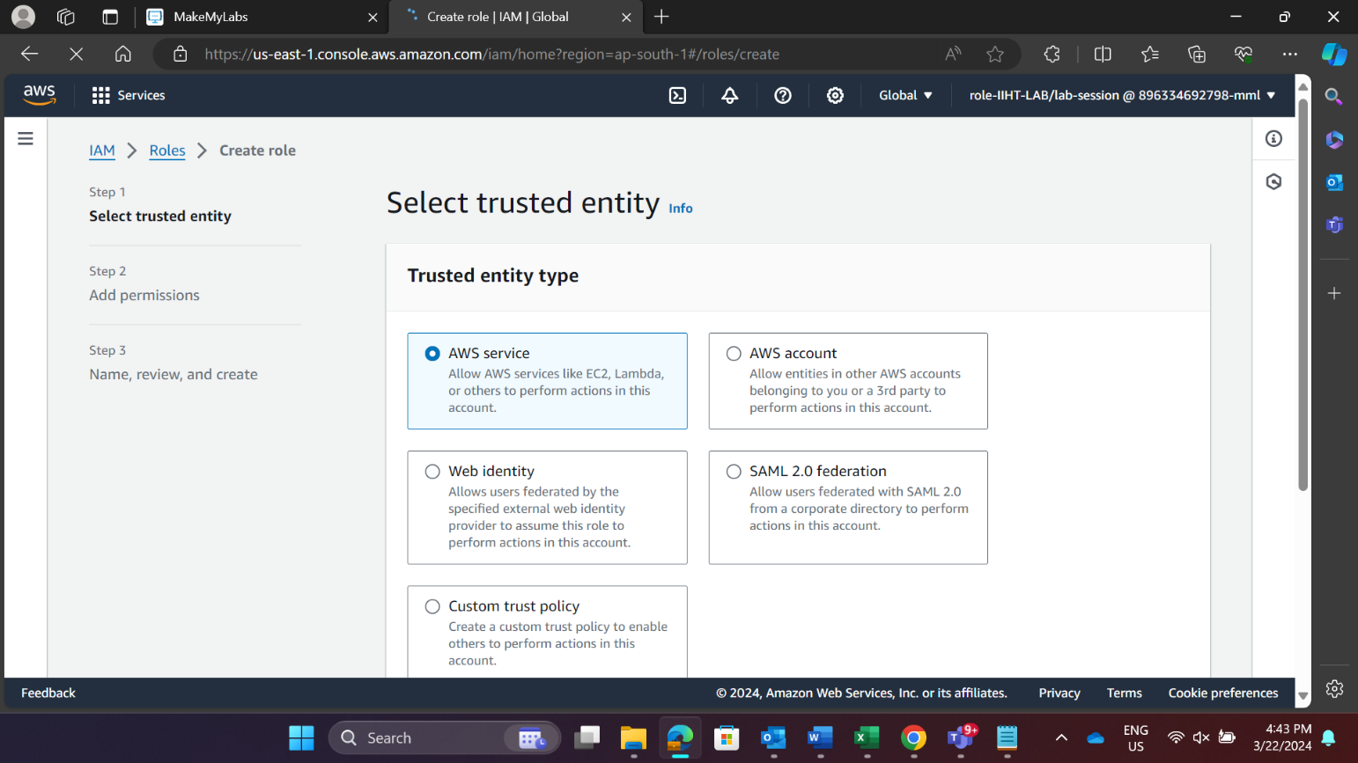

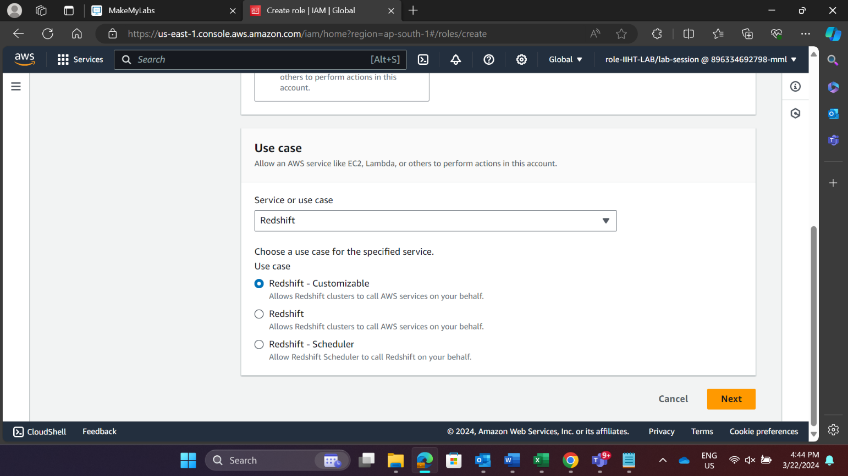

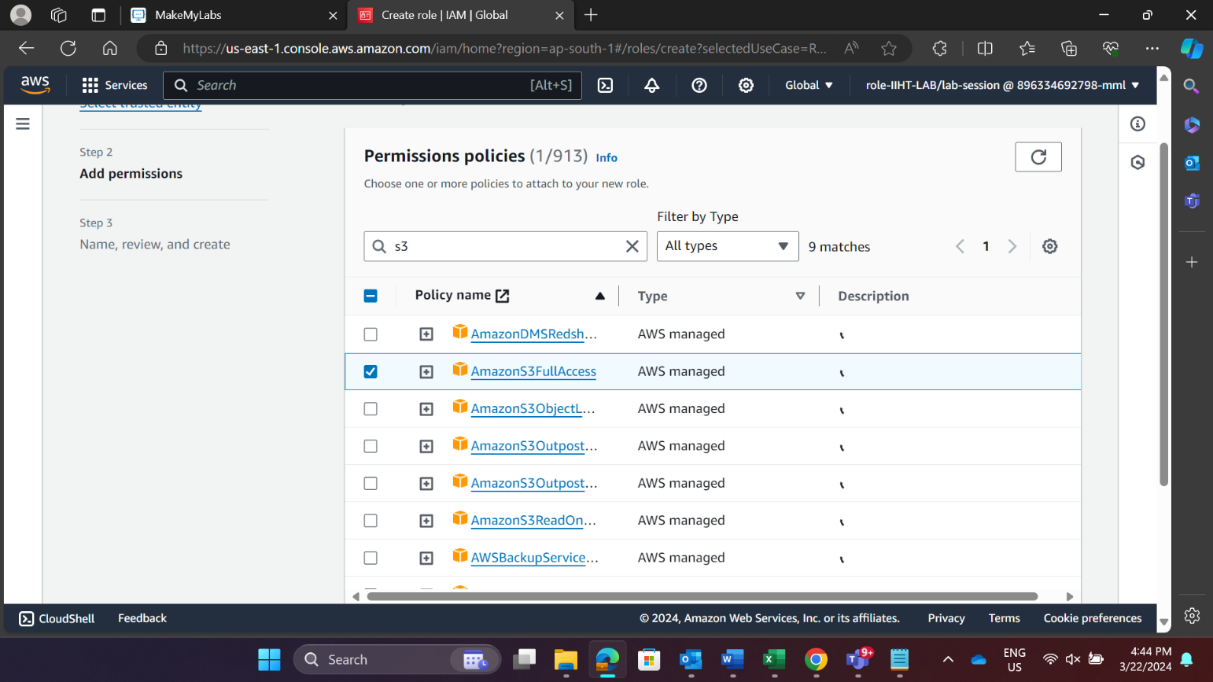

**Step 2:** Provide the details and finally create the role.

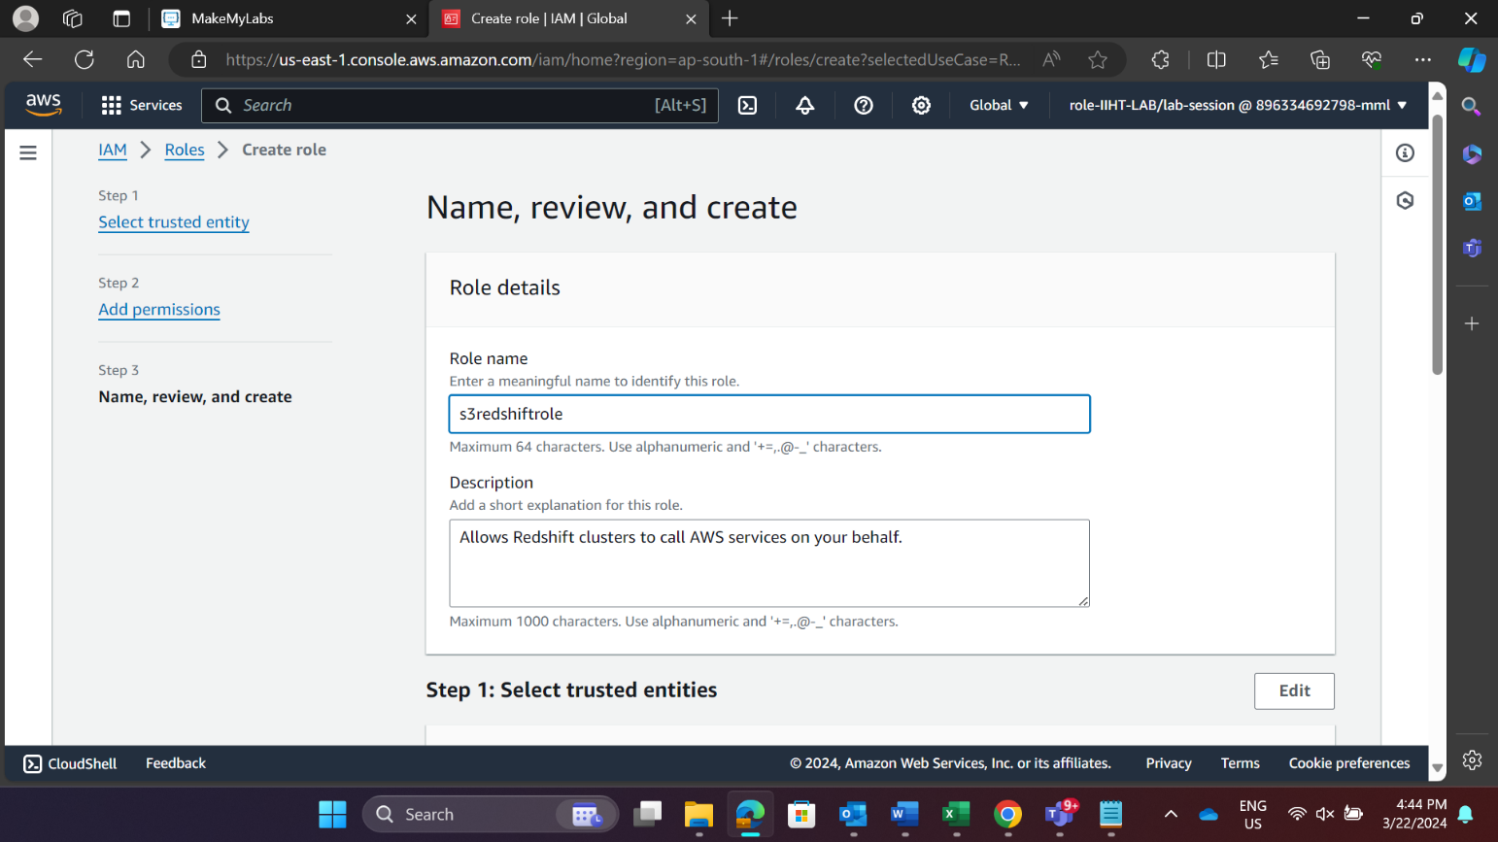

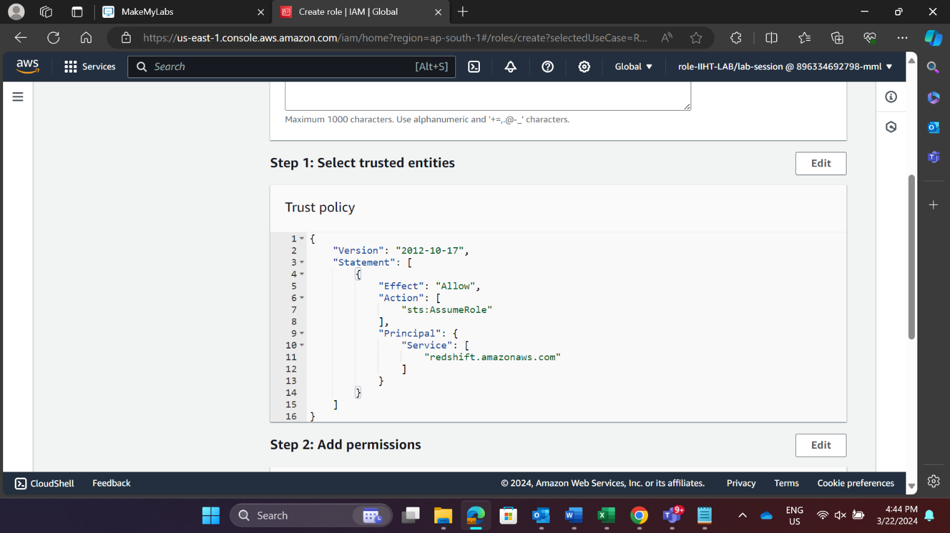

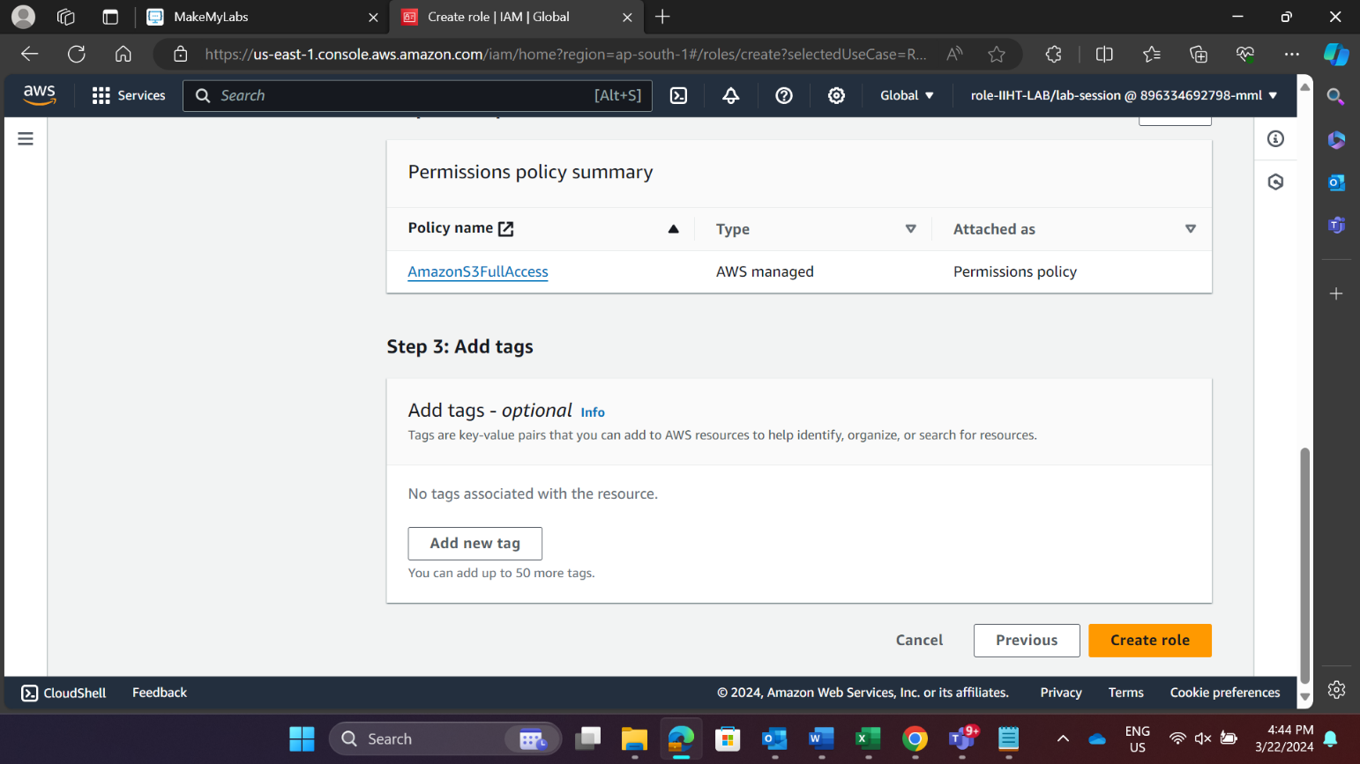

**REDSHIFT CREATION**

**Step1:** Sign in to the AWS Management Console and open the Amazon Redshift console and create the cluster. At upper right, choose the AWS Region where you want to create the cluster.

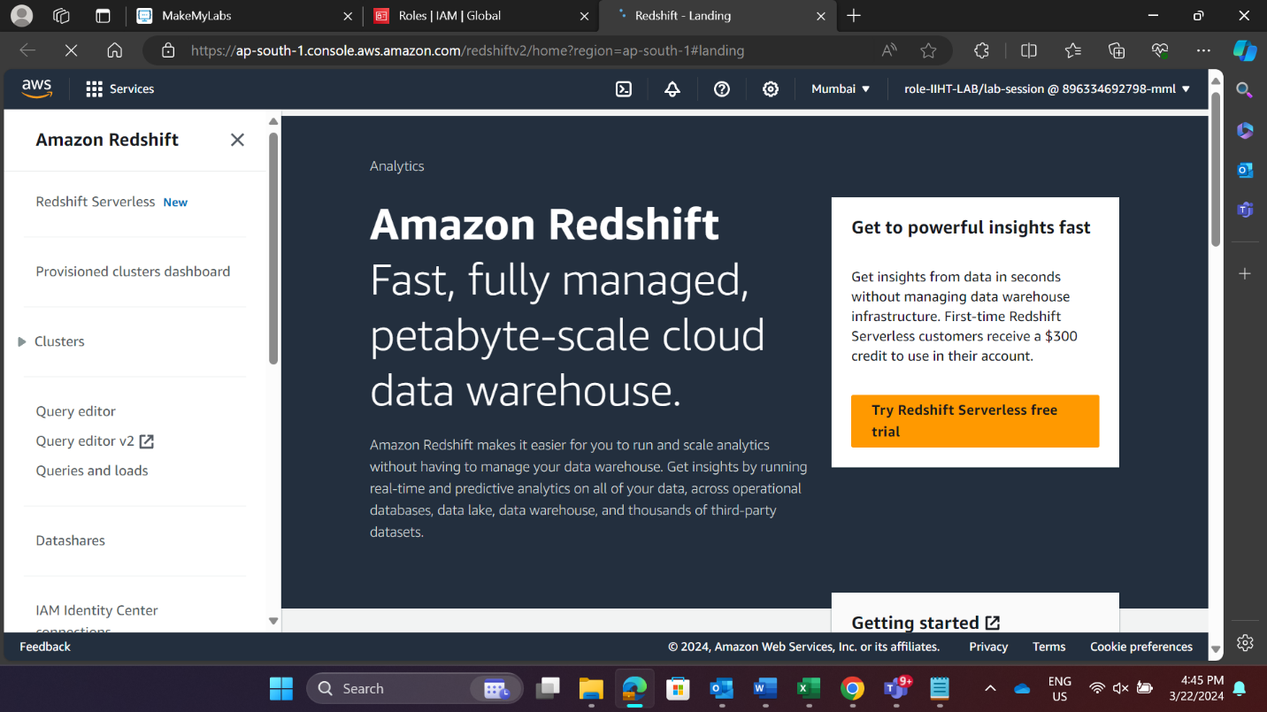

Choose **Clusters**, then choose **Create cluster** and start creating the cluster.

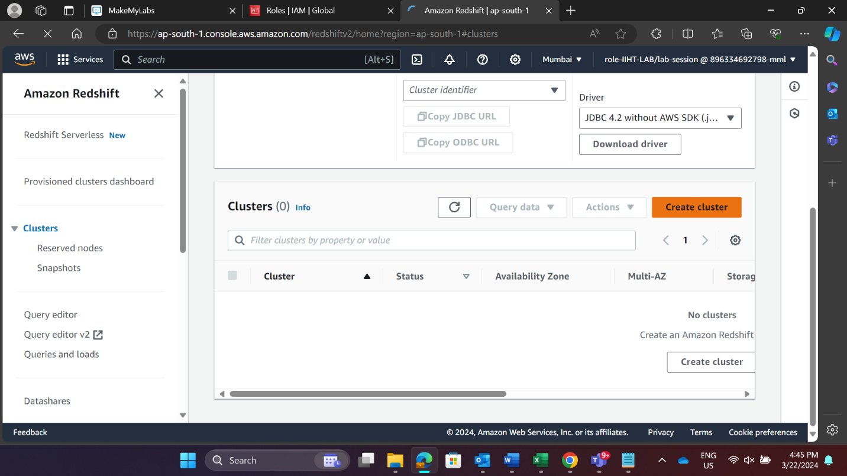

**Step 2:** In the Cluster configuration section, specify values for Cluster identifier and size of the cluster.

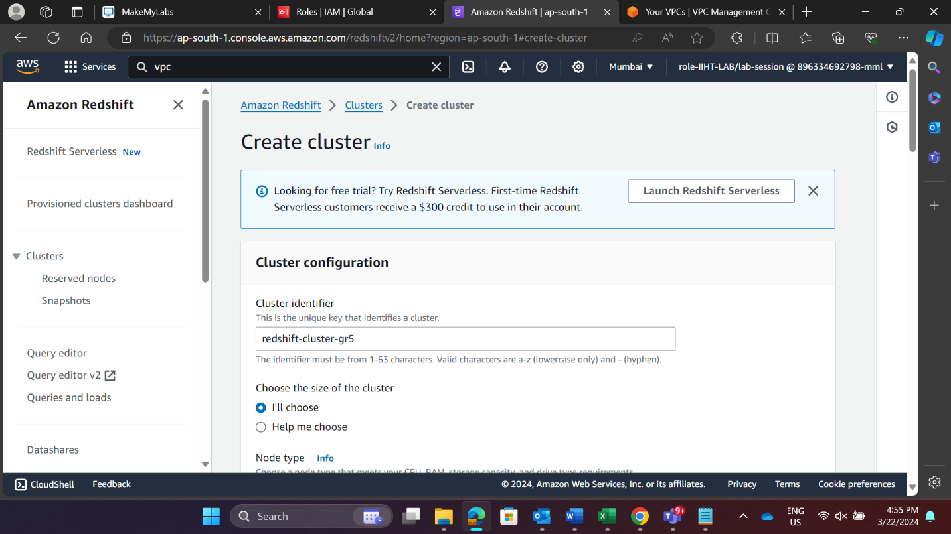

Then choose the **Node type** and number of **Nodes** to size your cluster. Choose dc2.large Node type and 1 for Nodes.

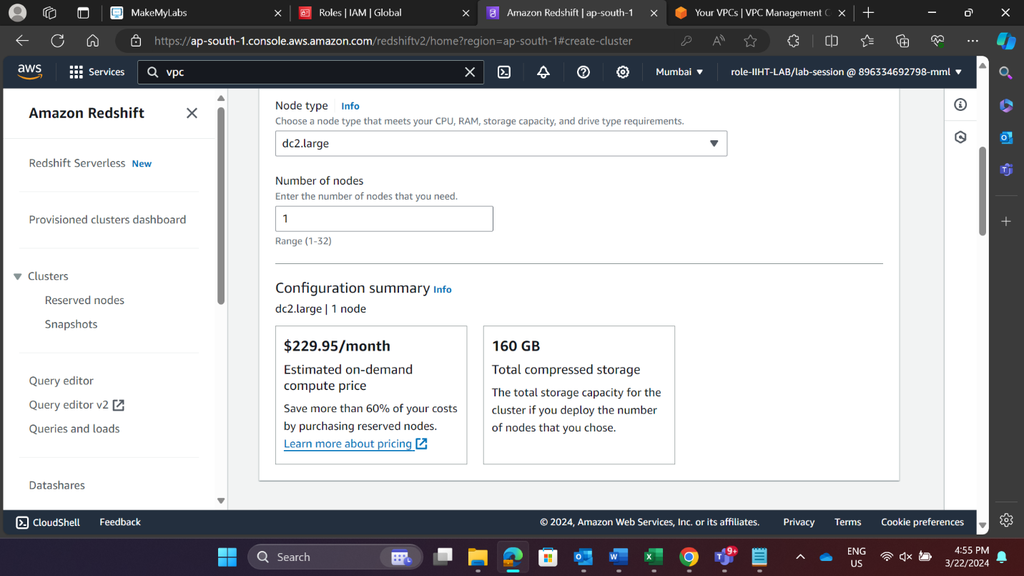

**Step 3:** In the Database configuration section, specify a value for **Admin username**. Choose Admin password as follows:

**Manually add an admin password** (Use your own password).

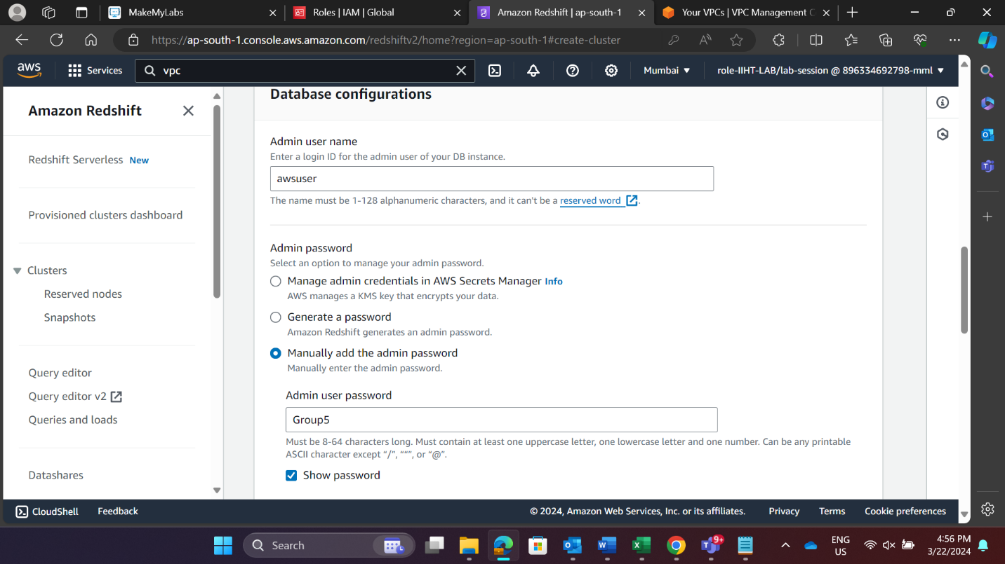

**Step 4:** Create an IAM role and choose the one you have created for your cluster. Under Cluster permissions, for Manage IAM roles.

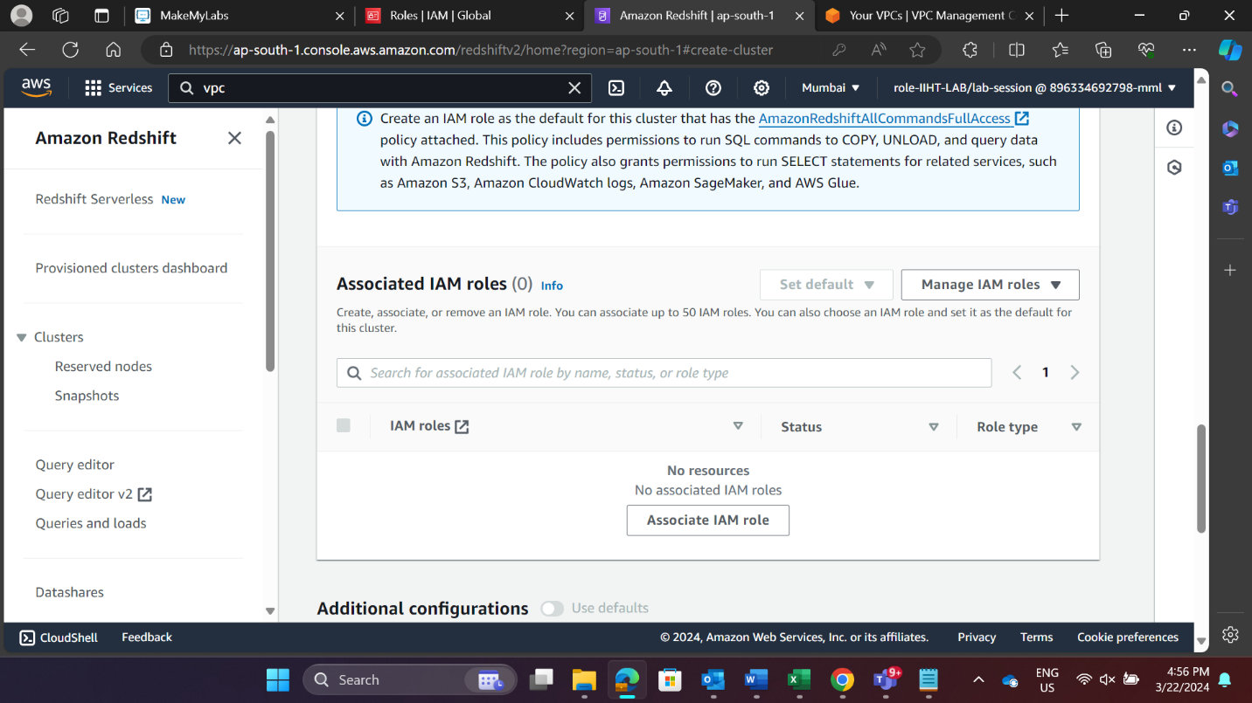

Specify an Amazon S3 bucket for the IAM role to access then Associate IAM role.

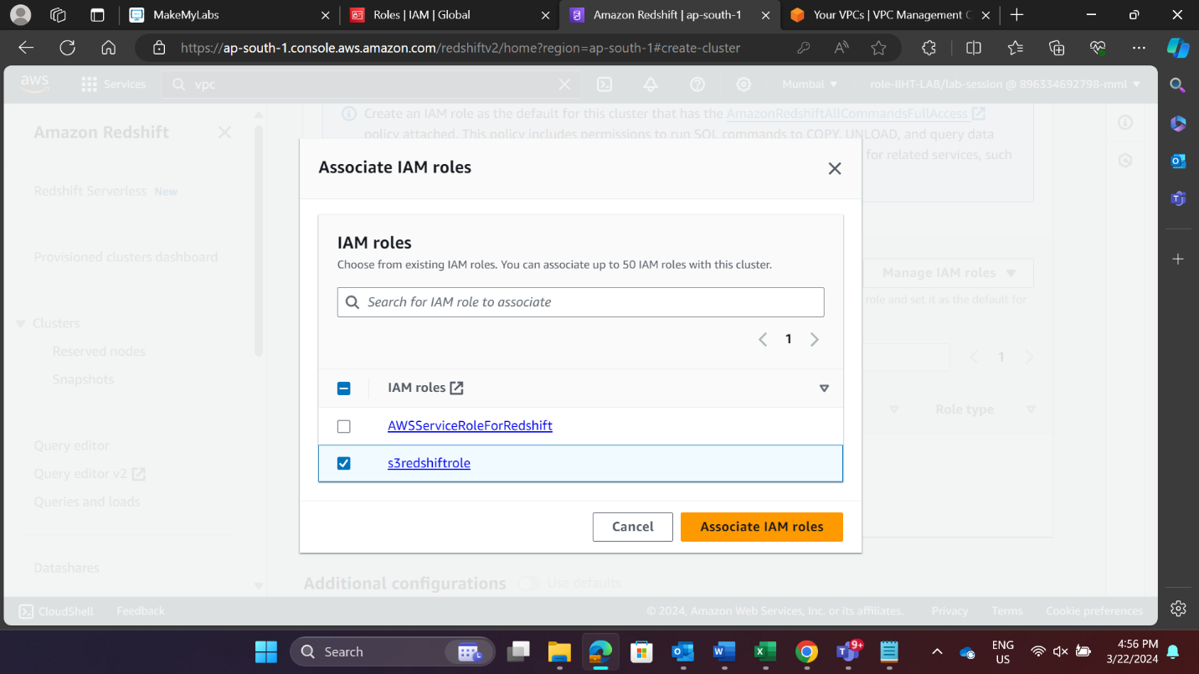

**Step 5:** Choose the VPC that you have created previously and set the VPC security groups as default.

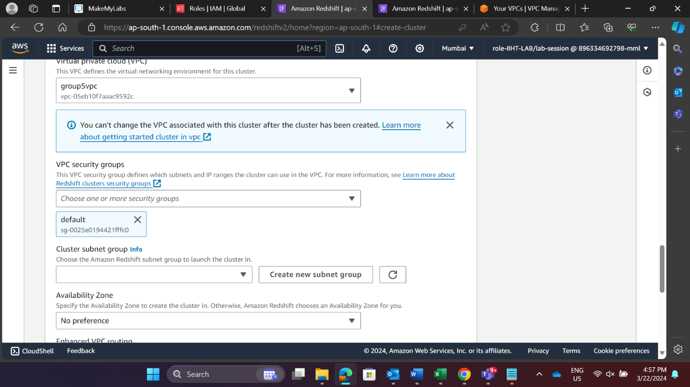

**Step 6**: Create a cluster subnet group. A cluster subnet group allows you to specify a set of subnets in your VPC.

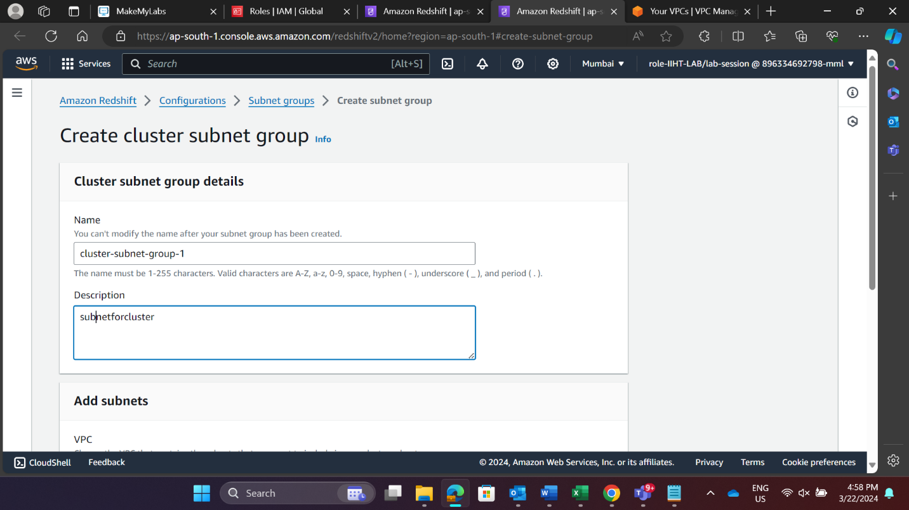

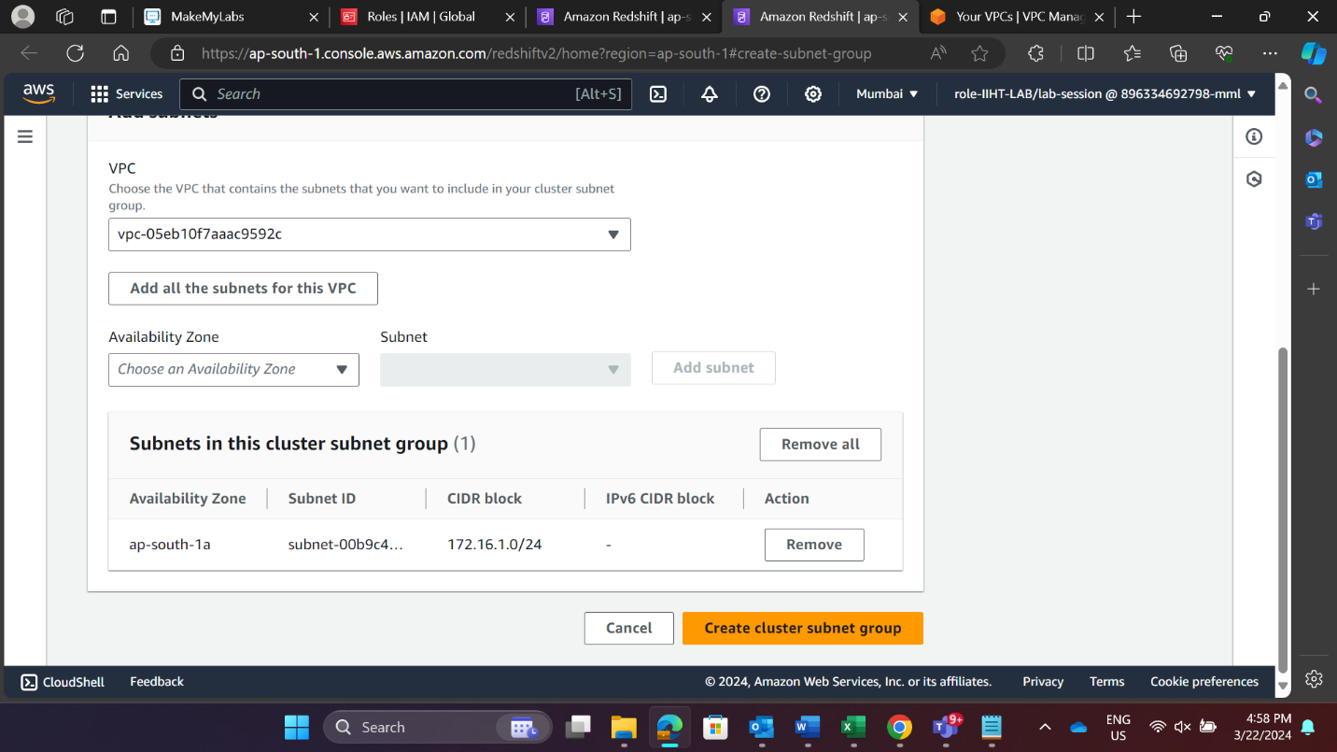

**Step 7:** Choose the Availability Zone in which location should subnet run.

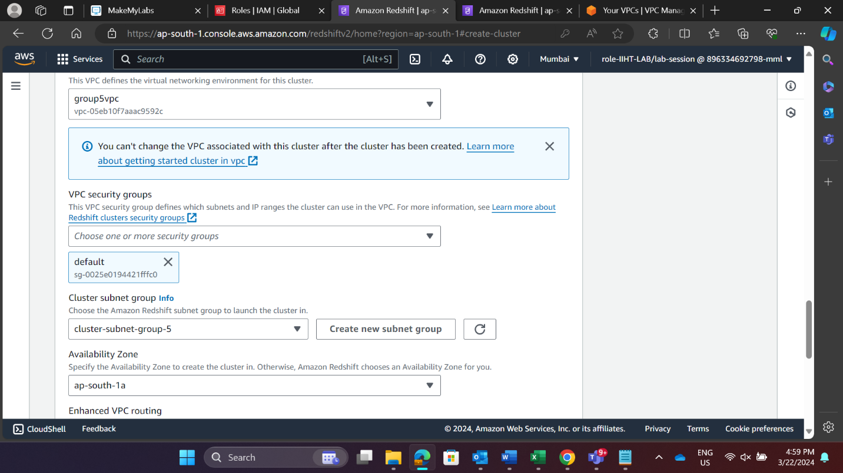

Turn on **“publicly accessible”**. This allows public connection to redshift.

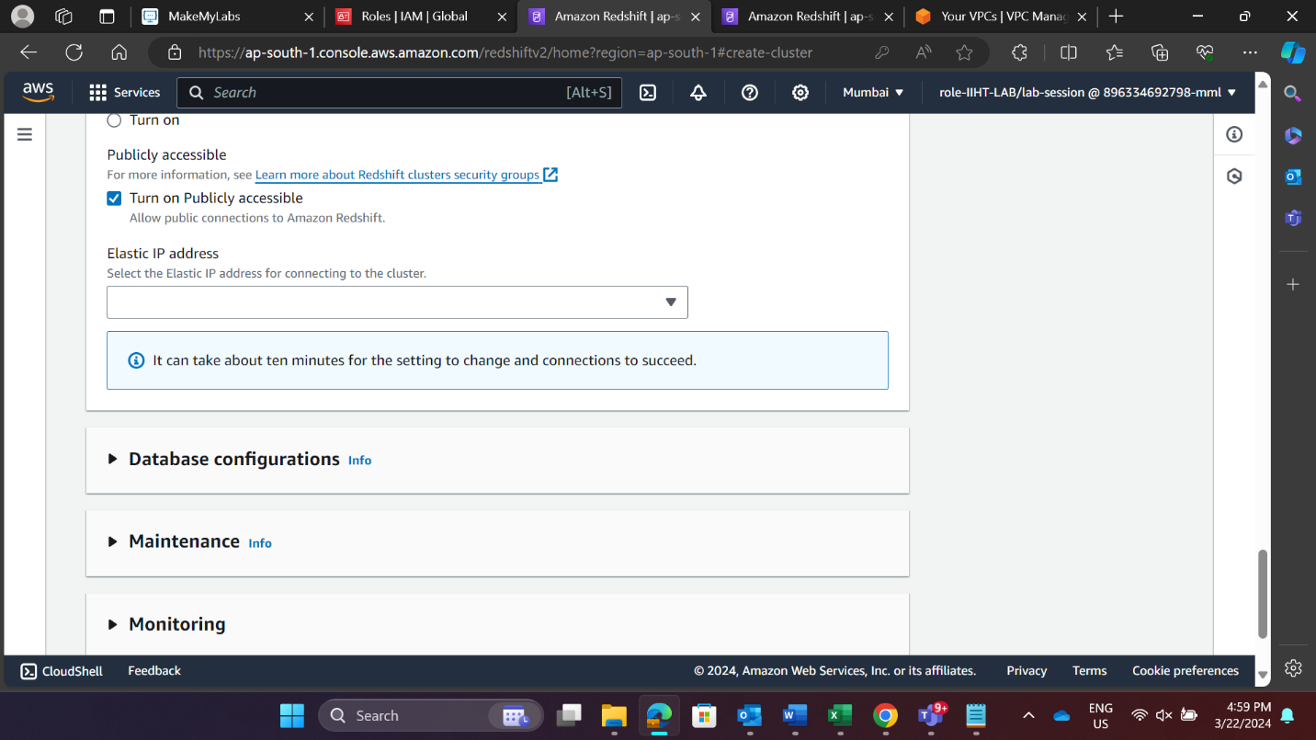

After completing the configuration setup “Create the cluster”

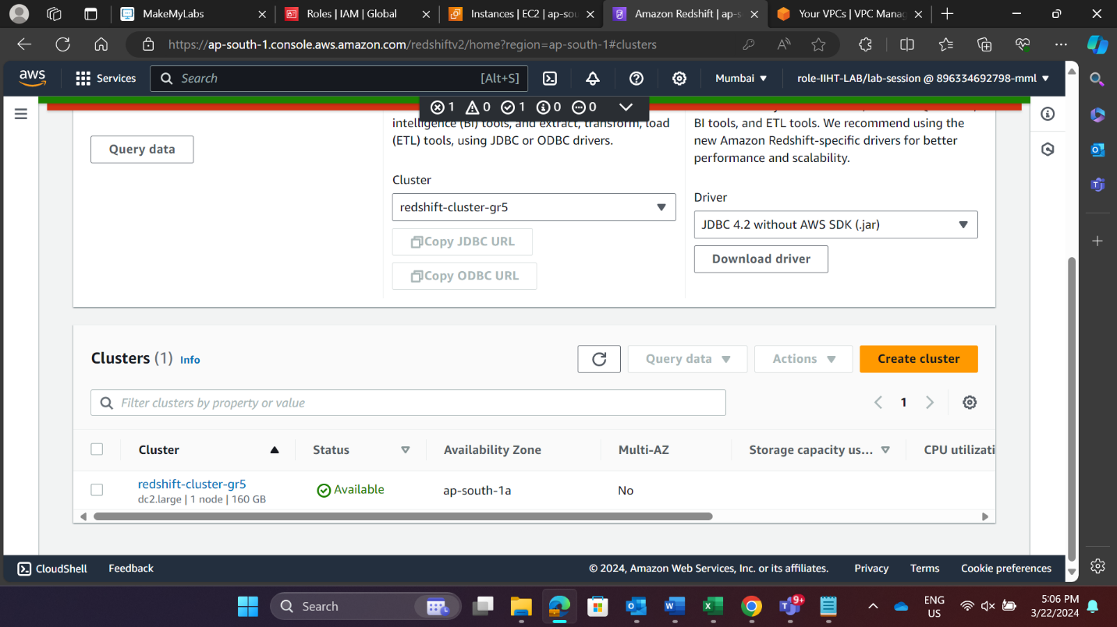

**Step 8:** Edit inbound rules under security groups and grant inbound access to cluster.

To access from an Amazon EC2 external, add a rule to the security group attached to your cluster that allows inbound traffic.

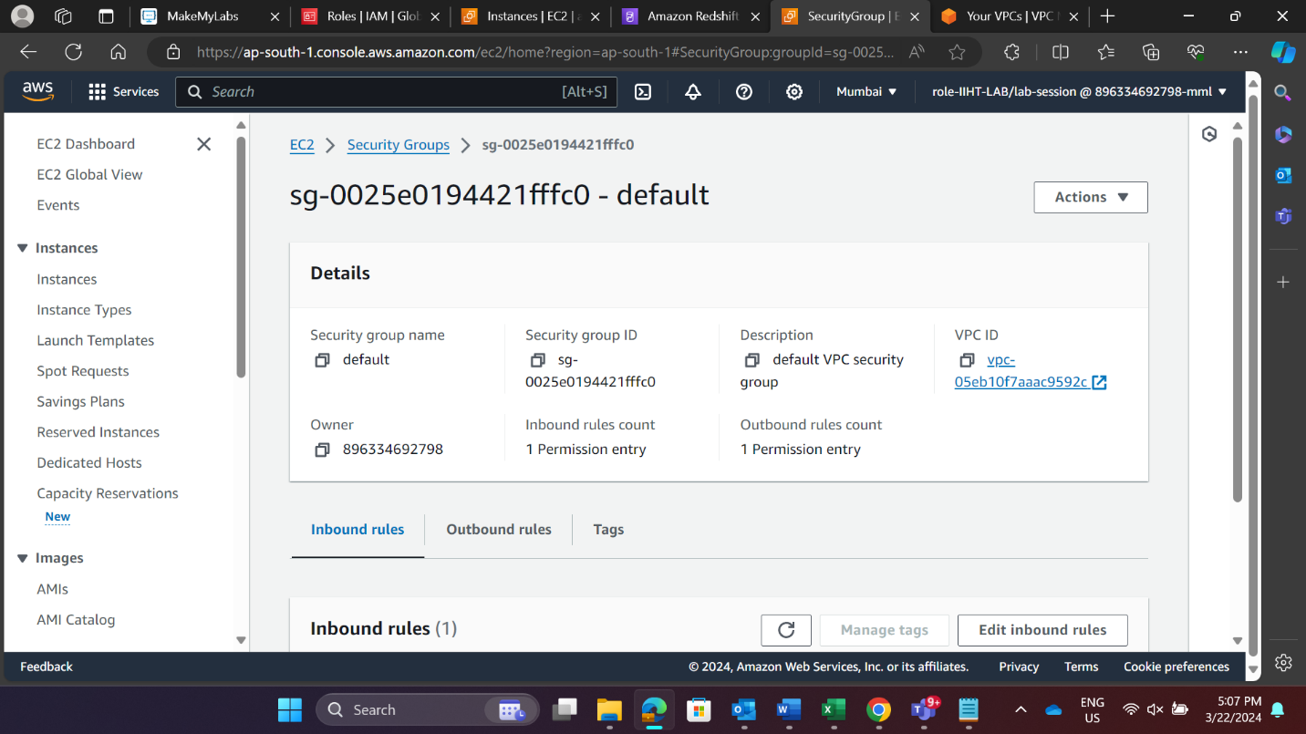

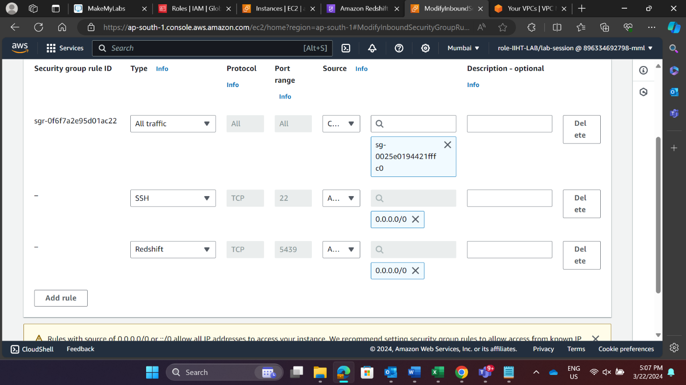

**Step 9:** After creating your cluster, you can immediately run queries using the Amazon Redshift console.

To query databases through Amazon Redshift cluster,

* Connect to your cluster and run queries on the AWS Management Console with one of the query editors.
* Connect to your cluster through an SQL client tool, such as SQL Workbench

**Redshift Queries Generation and Visualization**

1. Fetch the sales target, customer satisfaction ratings, and productivity for all the employees of the sales department.
2. Query execution.

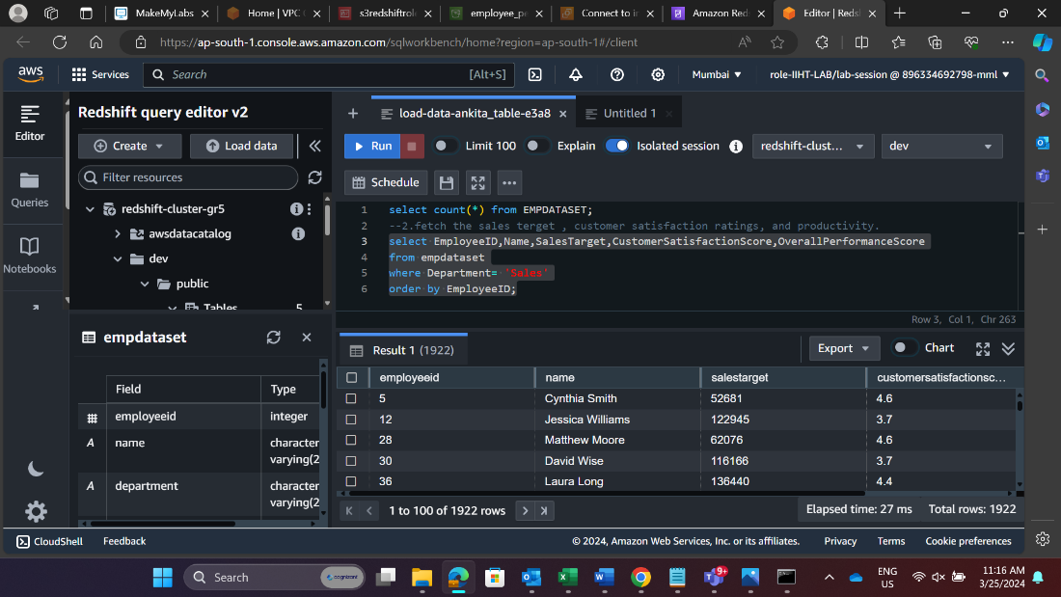

1. Visualization

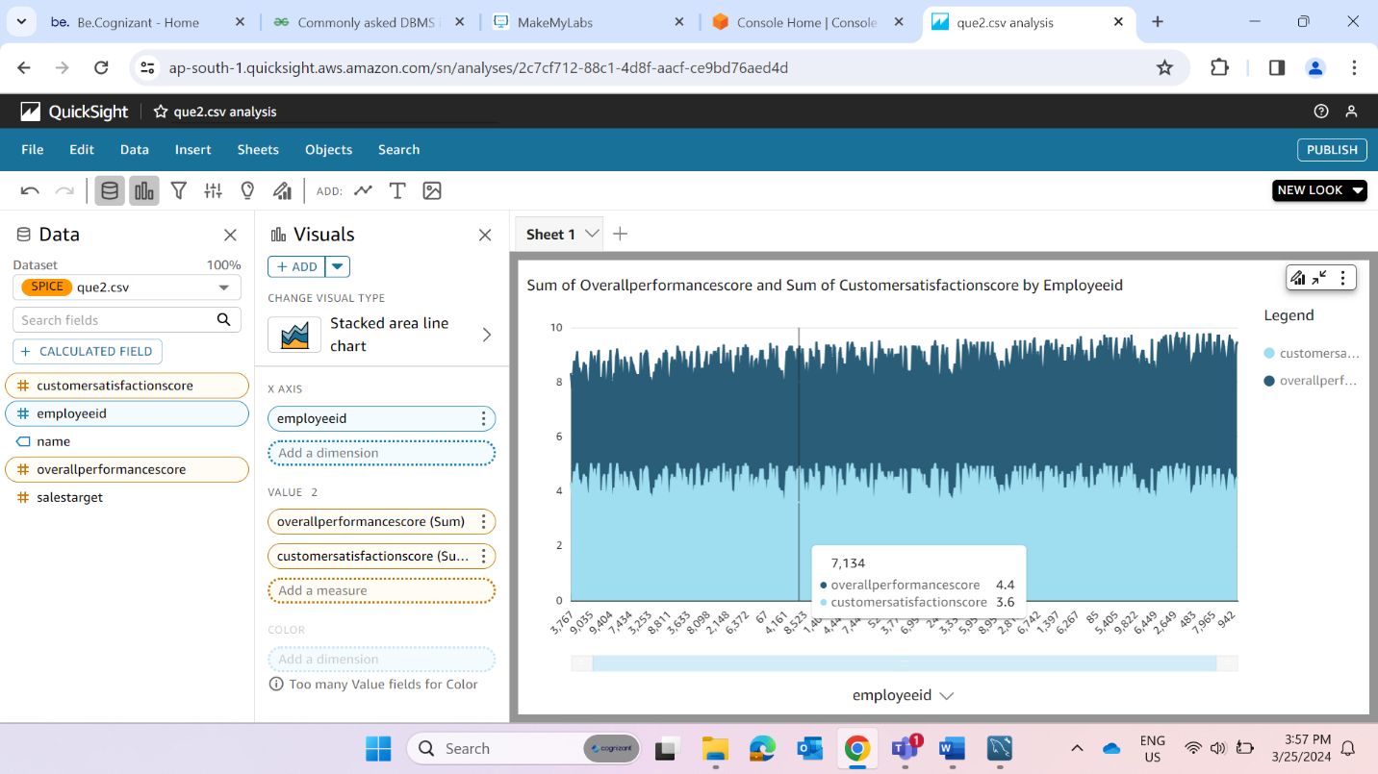

1. Identify top-performing employees by analyzing performance metrics and comparing them to predefined targets or benchmarks.
2. Query Execution

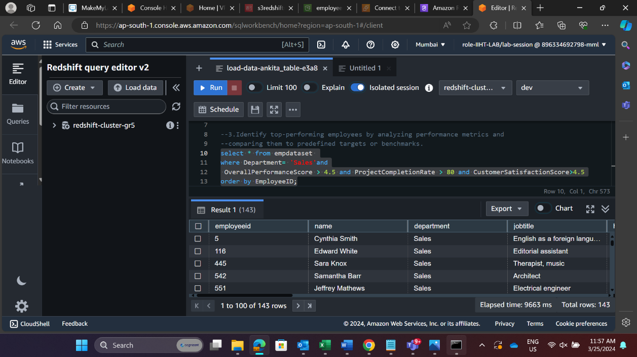

1. Visualization

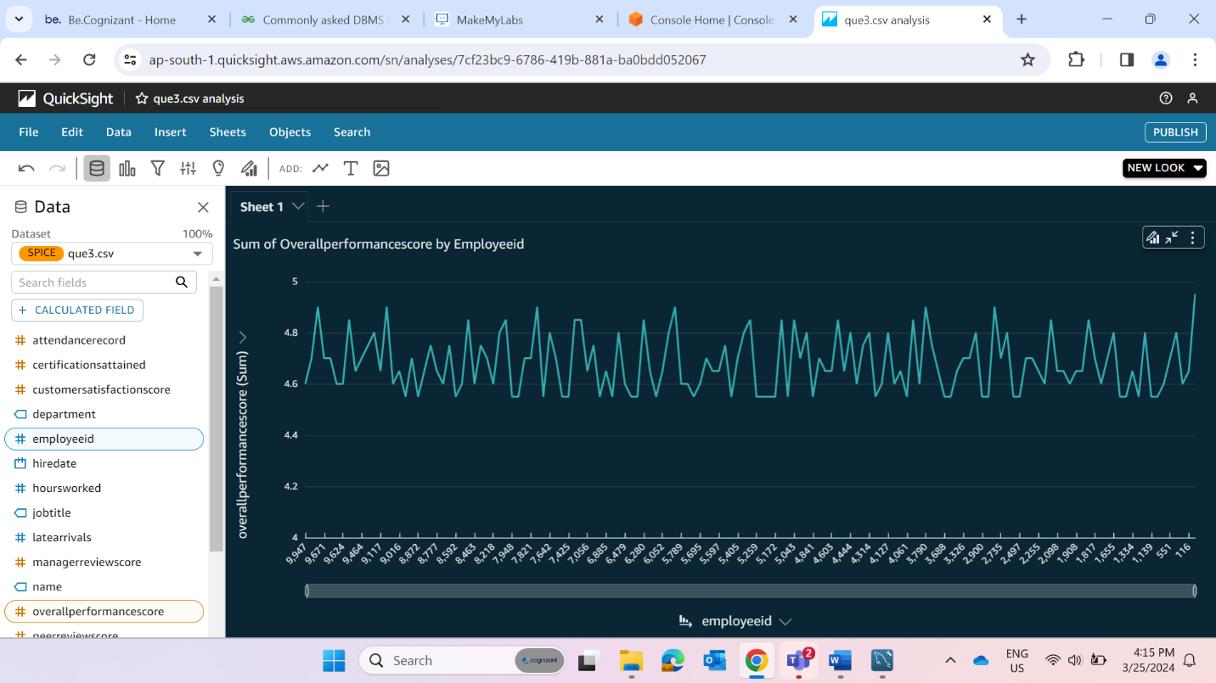

3. Identify the employees having low performance in the sales department.

a. Query Execution

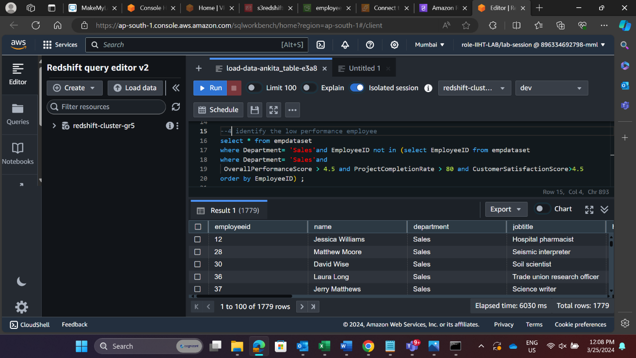

b. Visualization

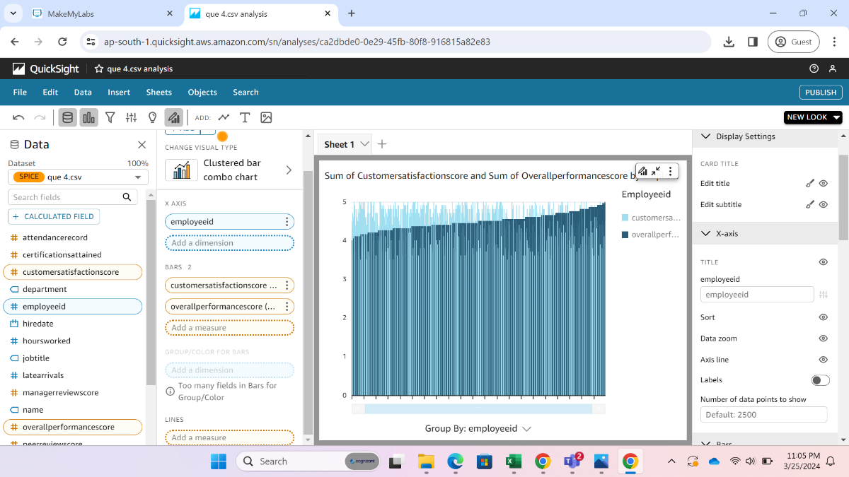

4. Give a performance value to all the employees of the sales department based on some specified criteria.

a. Query Execution

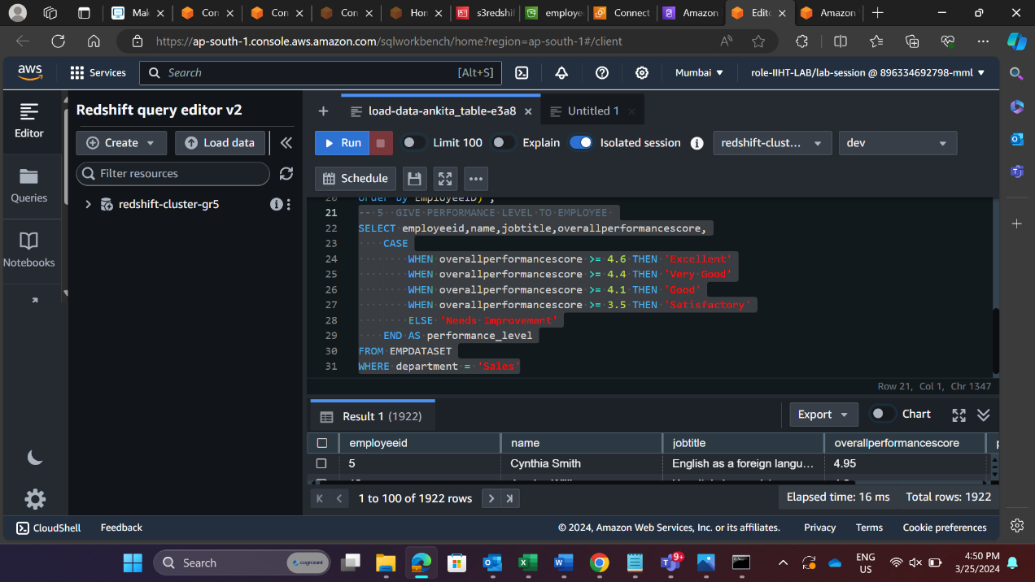

b. Visualization

5. Calculate the average, minimum and maximum salary of each department in the employee table.

a. Query Execution

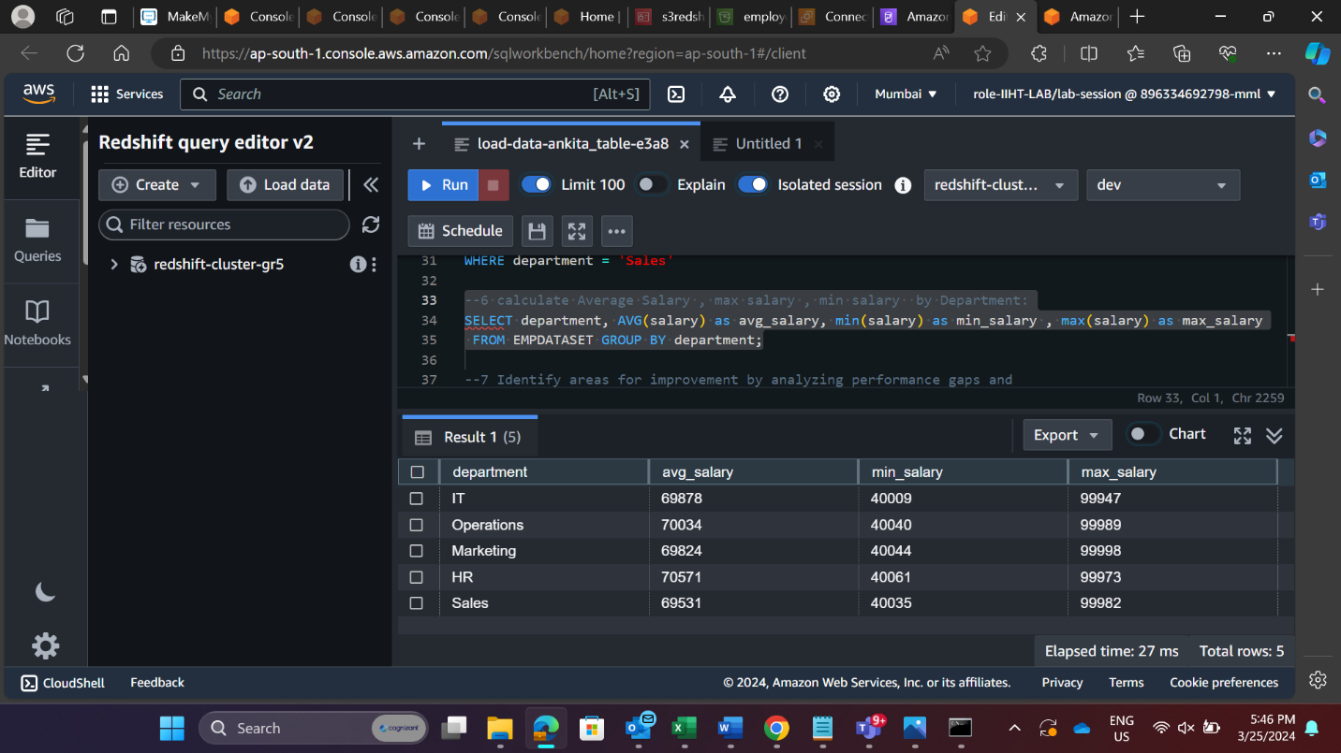

b. Visualization

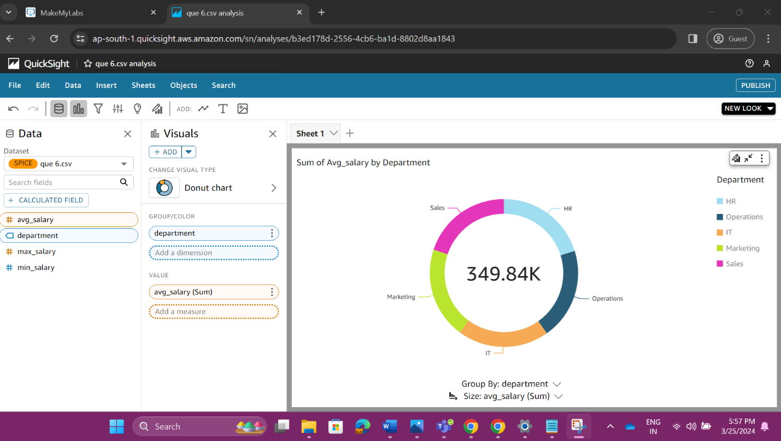

6. Identify areas for improvement by analyzing performance gaps and providing targeted training or support.

a. Query Execution

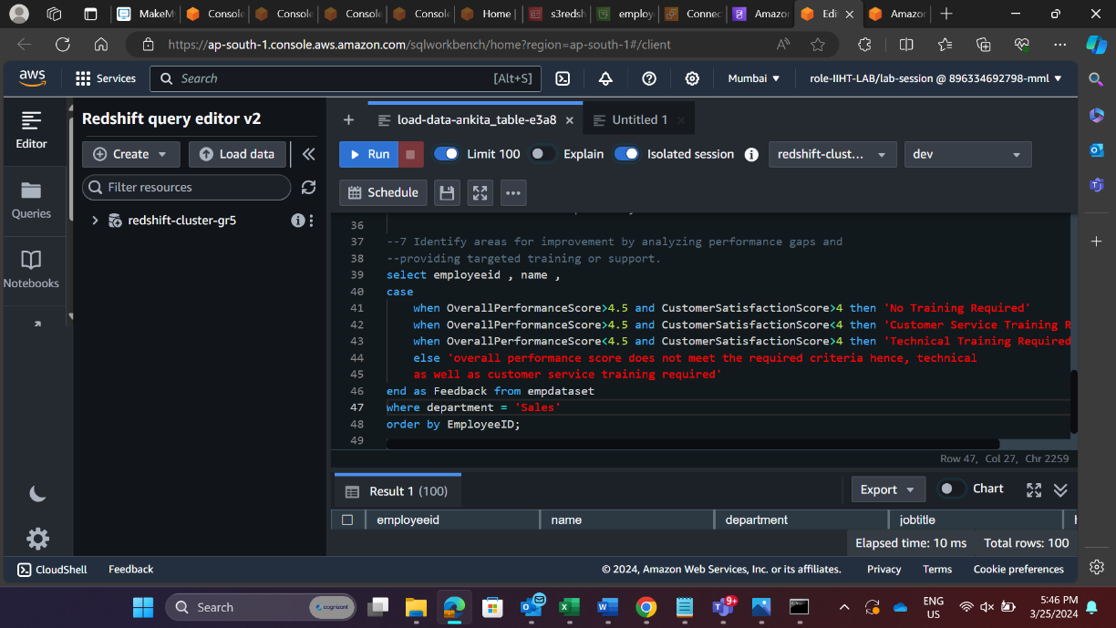

b. Visualization

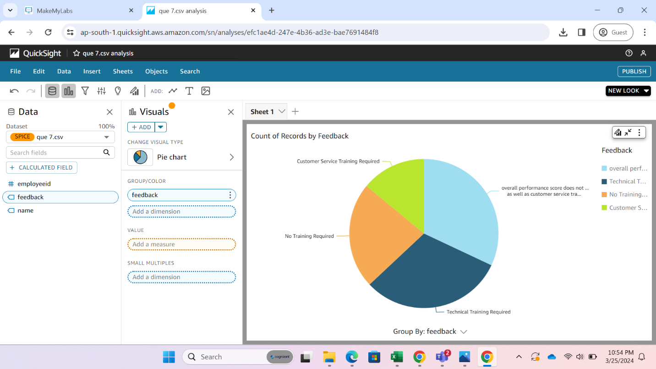

**CONCLUSION**

In conclusion, the project exemplifies the seamless integration and powerful capabilities of AWS services in constructing a robust data infrastructure. By harnessing Amazon S3 as a scalable storage solution, we ensured the efficient and secure handling of our datasets. The coupling of S3 with Amazon Redshift allowed for the establishment of a high-performance data warehousing environment, facilitating quick access and analysis of our structured data. Moreover, the utilization of Amazon EC2 instances enabled us to execute complex SQL operations, ensuring the manipulation and transformation of data according to our analytical needs.

Furthermore, the deployment of AWS Quicksight for visualization added a layer of insight to our data exploration process. With Quicksight's intuitive interface and comprehensive visualization options, we were able to craft informative reports and dashboards that provided stakeholders with clear and actionable insights. This not only enhanced our understanding of the underlying data but also empowered decision-makers to make informed choices based on the analyzed information.

In summary, the successful execution of this project underscores the value proposition of AWS as a leading cloud provider for data analytics initiatives. The combination of S3, Redshift, EC2, and Quicksight offered a cohesive and scalable solution that streamlined the entire data processing pipeline. As organizations continue to grapple with increasing volumes of data, leveraging AWS services provides a reliable and efficient means to extract actionable insights and drive business outcomes. Moving forward, the lessons learned from this project will serve as a foundation for future endeavors in harnessing the full potential of cloud-based data analytics solutions.